Web-Based Room Allocation and Reservation System with Artificial Intelligence-Based Conflict Detection and Administrative Approval
A research proposal presented to the
College of Computer Studies
of
First City Providential College

In partial fulfillment of the
requirement for the course
Capstone Research

Conducted by:

Angelo E. Borcena
Ayana Gail C. Soriano
Jhusnine Nicole B. Mariano
John Rey T. Camacho
Kenneth James R. Corbilla
Maeca Vinson

Submitted to
Mr. Adrian Cantonjos
Research Adviser

Chapter I
THE PROBLEM AND ITS BACKGROUND
Rationale
Managing scarce academic resources, especially classrooms and instructional spaces, is becoming increasingly difficult for educational institutions across the globe. Universities must effectively distribute available classrooms while taking into account room capacity, course requirements, instructor needs, and scheduling constraints as student populations, academic programs, and course offerings continue to grow. Higher education institutions must balance space utilization, room suitability, scheduling conflicts, and the needs of various academic stakeholders, making classroom allocation a complex planning issue (Oude Vrielink, 2025). Thus, effective and data-driven allocation can enhance the overall management of academic resources and lead to better use of instructional spaces.

Classroom allocation remains a difficult and time-consuming process, according to studies on university scheduling conducted globally. Room conflicts, inappropriate room assignments, unused classroom capacity, and scheduling overlaps are some of the critical issues related to room allocation that Antunes-Batista et al. (2026) noted. When assigning rooms, their study focused on the use of multiobjective optimization techniques that take into account variables like classroom capacity, room type, student relocation, room utilization, and scheduling constraints. These results highlight the significance of implementing methodical and automated strategies to enhance classroom distribution, optimize space utilization, and reduce scheduling conflicts in higher education establishments.

At the local level, First City Providential College (FCPC) experiences challenges in managing classroom and faculty room allocation due to increasing scheduling demands and limited available spaces. Faculty members and administrative personnel rely on manual processes for room assignment, reservation requests, and schedule monitoring, which frequently leads to overlapping schedules, delayed approvals, and inefficient room utilization. Observations within the institution indicate that the absence of a centralized room management system makes it difficult to monitor room availability in real time, validate reservations, and immediately identify scheduling conflicts. These local challenges reflect broader global and national concerns regarding the need for automated classroom allocation, reservation management, and conflict detection systems in educational institutions.

Despite advancements in modern technology, recent literature emphasizes the importance of implementing digital solutions for efficient room management. Hale et al. (2025) developed a classroom reservation mobile application that addressed challenges associated with manual booking processes by providing structured digital reservations. Similarly, Rodiyah et al. (2025) introduced a classroom reservation information system designed to enhance administrative operations through a web-based reservation process. Furthermore, García-Granja et al. (2022) explored reservation systems for educational facilities and emphasized that technology-based solutions can optimize space management, accessibility, and utilization. These studies demonstrate the potential of automated systems in reducing scheduling conflicts, minimizing administrative workload, and supporting more effective allocation of academic resources.

Although these studies show how successful digital reservation and classroom management systems are in a variety of educational contexts, the majority of current solutions concentrate more on room reservation and booking procedures than on the integrated distribution of faculty rooms and classrooms within a single system. Additionally, research like that conducted by Hale et al. (2025) and Rodiyah et al. (2025) was conducted in institutional settings distinct from FCPC, where scheduling accuracy is still impacted by manual procedures, a lack of administrative staff, and the lack of real-time conflict detection. This highlights a gap in the literature regarding the creation of a centralized, automated system that concurrently handles conflict detection, real-time availability monitoring, and classroom and faculty room allocation, especially in the context of a nearby higher education institution like FCPC.

To address this gap, the present study aims to design and develop a classroom and faculty room allocation system for First City Providential College. Specifically, the study seeks to (1) automate the process of room reservation and assignment to reduce scheduling conflicts and manual errors; (2) provide a centralized platform for real-time monitoring of room availability and reservation status; and (3) implement a conflict detection mechanism that immediately flags overlapping or invalid room assignments. Through these objectives, the study intends to improve the efficiency, accuracy, and reliability of classroom and faculty room management at FCPC, contributing to more effective utilization of institutional academic resources.

Framework of the Study

Conceptual Framework
This study uses the Development-Implement-Evaluate (D.I.E.) model as the research paradigm. It includes the supporting laws of the Philippines. Republic Act No. 10173 (Data Privacy Act of 2012) protects the personal information collected and processed by the reservation system, ensuring privacy, security, and confidentiality. Correspondingly, Republic Act No. 8792 (Electronic Commerce Act of 2000) recognizes the legality of online reservation requests, electronic approvals, notifications, and digital records. Moreover, it supports Sustainable Development Goal number 9: Industry, Innovation, and Infrastructure by introducing an innovative digital platform that modernizes the management of institutional facilities. Instead of relying on manual reservation procedures, the system improves room reservation and allocation by providing centralized room availability, conflict detection, and administrative approval.
First City Providential College's lack of a centralized, automated system for allocating classrooms and faculty rooms is the main issue that has been identified. This leads to scheduling conflicts, delayed approvals, and inefficient use of institutional spaces. The Web-Based Room Allocation and Reservation System with Artificial Intelligence-Based Conflict Detection and Administrative Approval, which integrates centralized scheduling, automated conflict screening, and a structured administrative approval workflow, is the study's proposed intervention to address this. Continuously updated room availability monitoring, fewer scheduling conflicts, quicker reservation processing, and enhanced institutional decision-making through precise and easily accessible reservation records are among the anticipated results of this intervention.
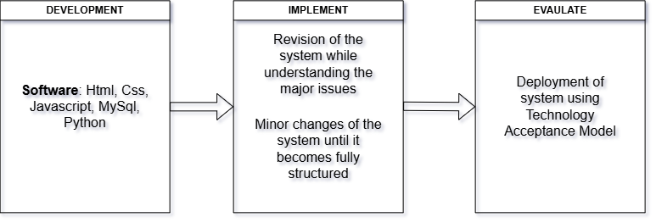
Figure 1: Paradigm of Study

Figure 1 illustrates the Development-Implement-Evaluate (D.I.E) conceptual framework of the study; it explains room reservation with artificial intelligence conflict detection and administrative approval. This figure shows the software requirements that include the revision and refinement of the system, with a combination of testing using the Technology Acceptance Model. The development section of the frameworks includes the main backbone of the system. HTML, CSS, JavaScript, and Python are used in the development of the system and its user interface and functionality. MySQL is used to store and manage user accounts, room information, reservation records, and other system data.

These developments ensure a solid foundation for the system. The implementation section describes the process of putting the developed system into use for testing. It includes the identification of necessary revisions and adjustments based on the results of testing to improve the quality and functionality of the system. Using this implementation, the system will be more structured and user-friendly. The evaluation section shows the testing phase of the system. It includes feedback, user experience, and testing using the technology acceptance model.

This section evaluates the performance and acceptability of the system based on the feedback gathered during testing. Overall, Figure 2.1 illustrates the procedure of development, implementation, and evaluation. This framework emphasizes the accountability of the system and securing all the data of the users and administrators; furthermore, it supports improvements and less hassle of room reservation at First City Providential College.

Theoretical Framework
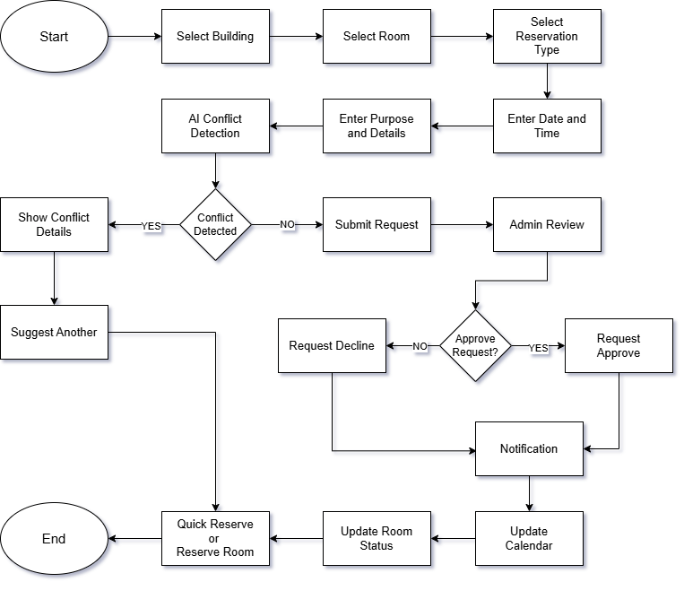
Figure 2. Theoretical Framework
Figure 2 demonstrates the flow of reservation from selecting the building and rooms until the reservation of the rooms. The Constraint Satisfaction Problem Theory (CSP) connects the room allocation and reservation involving assigning rooms and time slots while satisfying several constraints. Also, the system can evaluate these constraints to determine whether the requested room and schedule are valid or conflict with an existing reservation (Montanari et al., 1974).

Likewise, Decision Support Systems (DSS) focus on the use of computer-based systems to support decision-making by providing relevant information, analytical capabilities, and alternatives to decision-makers. Furthermore, it can also collect and analyze information such as room availability, reservation schedules, room capacity, and requested dates and time periods (Peter & Michael, 1978). Similarly, according to Fred (1989), the Technology Acceptance Theory (TAM) can be useful and is perceived to have two primary factors that influence the technological system. This theory can demonstrate room reservation, provide real-time room availability, detect scheduling conflicts, reduce manual work, and facilitate administrative approval.

Overall, these theories can address the technical decision-making and user acceptance aspects. The CSP supports the system detecting conflicts and managing allocation; the DSS supports the system and assists administrators in making approval decisions; and lastly, the TAM supports the evaluation of user acceptance and usability.

Objectives of the Study
General Objective
This study aims to develop and evaluate a Web-Based Room Allocation and Reservation System with Artificial Intelligence-Based Conflict Detection and Administrative Approval to improve the room reservation and allocation process at First City Providential College through centralized room availability monitoring, reservation management, conflict detection, and administrative approval.

Specific Objectives of the Study
Specifically, this study seeks to:
- analyze the existing room allocation and reservation process at First City Providential College, including the challenges encountered by faculty members and administrators;
- design and develop a web-based room allocation and reservation system with features such as:
a. room and facility availability monitoring;
b. room reservation requests;
c. Artificial Intelligence-Based Conflict Detection;
d. administrative approval;
e. room and building management;
f. reservation monitoring; and
g. report generation;
- evaluate the proposed system through Alpha Testing conducted with Information Technology experts to identify necessary revisions and improve its functionality;
- evaluate the proposed system through Beta Testing among faculty members and administrators using the Technology Acceptance Model (TAM) in terms of:
a. perceived usefulness;
b. perceived ease of use; and
c. behavioral intention to use; and
- propose the implementation and utilization of the Web-Based Room Allocation and Reservation System at First City Providential College based on the results of the Beta Testing and evaluation.

Statement of the Problem
This study aims to develop a Web-Based Room Allocation and Reservation System with Artificial Intelligence-Based Conflict Detection and Administrative Approval for First City Providential College to improve room utilization and save time in the reservation process.

Specifically, this study seeks to answer the following questions:
- What are the current operational challenges and scheduling conflicts encountered by faculty members and administrators in the existing room reservation process?
- How can the web-based system be designed and developed to integrate AI-based conflict detection, room availability monitoring based on reservation records, and administrative approval workflows?
- What is the level of technical functionality and performance of the developed system based on the evaluation of Information Technology experts?
- What is the level of acceptability of the system among faculty members and administrators based on the Technology Acceptance Model (TAM) in terms of:
a. perceived usefulness;
b. perceived ease of use; and
c. behavioral intention to use?
- What implementation and utilization plan can be proposed for the institutional adoption of the system based on the findings of the study?

Scope and Delimitation
The development and validation of a Web-Based Room Allocation and Reservation System with Artificial Intelligence-Based Conflict Detection and Administrative Approval for First City Providential College during the academic year 2025-2026 is the focus of this study. The system covers the institution’s buildings, including classrooms and non-classroom facilities such as the gymnasium. Faculty members and authorized student representatives can use the system to check the availability of rooms and facilities, submit reservation requests, and track the status of their requests. Administrators can manage rooms and buildings, review reservation requests, approve or reject requests, monitor room usage, and generate reports. Before a reservation request is approved, the system provides artificial intelligence-based conflict detection to identify conflicts involving the same room or facility, the same date, and overlapping reservation times. The respondents of the study include First City Providential College faculty members, administrators, and Information Technology specialists for Alpha Testing.

However, the study does not cover automatic class scheduling, automatic reservation approval, attendance monitoring, payment processing, or integration with other institutional information systems, as these functions are beyond the scope of room allocation and reservation management. The system’s artificial intelligence is limited to identifying scheduling conflicts based on reservation data and does not involve physical sensing of room conditions therefore, Internet of Things (IoT) devices are not included. Since First City Providential College has not installed closed-circuit television (CCTV) monitoring in every room, the system does not provide real-time verification of a room’s actual physical occupancy and instead relies on authorized reservation records to determine availability. Only faculty members and authorized student representatives who have been given permission by a faculty member to make reservations on the faculty member’s behalf are permitted to use the reservation function. This may apply, for example, when a faculty member is unable to make the reservation personally. The study is limited to First City Providential College therefore, its findings may not be directly generalizable to other educational institutions without further validation.

Significance of the Study
This study is significant to the following individuals and groups who may benefit from the development and implementation of the Web-Based Room Allocation and Reservation System with Artificial Intelligence-Based Conflict Detection and Administrative Approval for First City Providential College.

Dean. The system provides the dean with a centralized view of room allocation and reservation activities within the college. Through the reports module, the Dean can monitor room utilization, review the status of reservation requests, and use the data as a basis for facility and resource management decisions.
Faculty. Faculty members benefit from a convenient and transparent process of reserving classrooms online. They can check room availability without repeated inquiries to the administrative office, submit reservation requests, and track the status of their bookings. The conflict detection feature minimizes scheduling clashes before a request reaches the administrator.

Authorized Student Representatives. Student representatives who request rooms on behalf of faculty members benefit from a faster and more organized process. They can verify room availability and submit requests through the system instead of relying on manual coordination, reducing the time spent on follow-ups with the administrative office.
Administrators. The system reduces the administrative effort involved in managing reservation requests. Instead of coordinating through paper records, spreadsheets, and verbal communication, administrators can review, approve, or decline requests, manage building and classroom records, monitor room utilization, and generate reports from a single platform.
Registrar. The registrar gains access to accurate and up-to-date records of room assignments and reservations. This supports the alignment of room allocation with academic schedules and provides reliable data for reporting and documentation. Apart from this, manual updating of room allocation recipes will become more efficient, as the current system relies on faculty arrangement.
Program Chairs. Program Chairs can monitor the reservation activities of faculty members under their respective programs and verify room availability before scheduling program-related activities, helping them coordinate the use of rooms within their departments more efficiently.
Students. Although students are not direct users of the system, they benefit indirectly from orderly and conflict-free room management. Faculty consultations and other academic activities proceed as scheduled, and classrooms remain properly assigned and available when needed.
Researchers. This study serves as a reference for future research on web-based room allocation, reservation management, conflict detection, and administrative approval in academic institutions. The findings, system design, and evaluation results may be used as baseline data for similar studies, particularly in Philippine higher education institutions.
Future Developers. The system can serve as a foundation or reference implementation for developers who intend to build, enhance, or maintain similar reservation systems. The documentation of its features, architecture, and development process guides future improvement.
First City Providential College. The institution as a whole benefits from improved utilization of its classrooms and faculty rooms, reduced double bookings and scheduling conflicts, digital record-keeping, and a more professional and efficient room management process.

Definition of Terms
The following terms are defined conceptually and operationally as they are used in this study.

Room Allocation. Room allocation refers to the systematic assignment of available rooms to users based on factors such as availability, preferences, and requirements. In this study, room allocation refers to the process in the system where an administrator assigns classrooms to faculty members, departments, or approved reservations based on availability and institutional needs.
Reservation Request. A reservation is submitted by a user who checks availability, selects a date and time, and reserves a slot through the system, which then holds that resource so it cannot be booked by someone else at the same time. In this study, a reservation request refers to the record submitted through the system containing the requested classroom, date, time, and purpose, which remains pending until it is approved or declined by an administrator.
Artificial Intelligence-Based Conflict Detection. Conflict detection is the logic that checks proposed bookings against existing events, resources, and scheduling rules before a booking is finalized; if an overlap or a violation of constraints occurs, the system blocks the slot or offers an alternative. In this study, artificial intelligence-based conflict detection refers to the feature of the system that compares a new reservation request with existing reservations and alerts the user and the administrator when an overlap in room, date, and time is detected, before the request is approved.
Administrative Approval. Administrative approval refers to the formal acceptance by an authority of a proposal submitted for consideration. In this study, administrative approval refers to the process in the system wherein an administrator reviews a submitted reservation request and approves or declines it before the reservation becomes final.
Web-Based System. A web-based system is an application that is accessed through a web browser using the HTTP protocol and can be used across multiple devices as long as there is an internet connection. In this study, a web-based system refers to the room allocation and reservation application of First City Providential College, which is accessed by faculty members, authorized student representatives, and administrators through a web browser. The system may be deployed through a local host during development and testing.
Classroom. A classroom is a room in a school or college in which classes are taught. In this study, classroom refers to any instructional room at First City Providential College that is managed through the system and may be reserved by faculty members and authorized student representatives for academic activities.
Authorized Student Representative. A class representative is a student nominated to represent fellow students and to serve as a conduit for communication between students and staff. In this study, an authorized student representative refers to a student permitted by First City Providential College to use the system to submit room reservation requests on behalf of faculty members.
Beta Testing. Beta testing is the second phase of software testing in which a sampling of the intended audience tries out the product in a real-world environment before its official release. In this study, beta testing refers to the evaluation phase in which faculty members and administrators assess the usability, functionality, reliability, and acceptability of the system using the Technology Acceptance Model.
Technology Acceptance Model (TAM). The Technology Acceptance Model is a theoretical framework that explains and predicts how and why individuals adopt information technology systems, based on two main determinants: perceived usefulness and perceived ease of use. The same constructs are central to the literature reviewed in this study. In this study, the Technology Acceptance Model refers to the instrument used during beta testing to measure faculty members' and administrators' perceived usefulness and perceived ease of use of the system.

Chapter II:
Review of Related Literature and Studies
This chapter presents the reviewed literature and studies relevant and pertinent to the present study. The materials consist of books, online articles, electronic resources, scholarly journals, and other reading materials that enabled the researchers in the conceptualization and operationalization of this research endeavor. The literature and studies are organized according to the major concepts and features of the proposed Web-Based Room Allocation and Reservation System with Artificial Intelligence-Based Conflict Detection and Administrative Approval for First City Providential College.

CONCEPTUAL LITERATURE
This section presents concepts, principles, and technologies related to the proposed system. The discussion focuses on the major terms identified in the study, including web-based systems, classrooms, room allocation, reservation requests, artificial intelligence-based conflict detection, administrative approval, authorized student representatives, beta testing, and the Technology Acceptance Model.
Web-Based Room Reservation and Classroom Allocation
Web-based room reservation refers to the use of an online system that allows users to view available rooms, select a preferred date and time, submit reservation requests, and monitor the status of their requests. Compared with manual reservation procedures, a web-based system provides a centralized platform where reservation information can be stored, accessed, and updated. This can help reduce dependence on paper forms, verbal communication, and separate records.
García-Granja et al. (2022) developed an innovative seat reservation system for university buildings using Building Information Modeling technology. Their work demonstrated how digital reservation technologies can support the management and utilization of university spaces. The study shows that reservation systems can provide users with information about available spaces while helping institutions organize the use of their facilities. This concept is relevant to the proposed system because it also provides a centralized method of viewing and reserving institutional rooms.
Chong et al. (2024) developed U-Reserve, a facility reservation system for UCSI University. The study demonstrated how a digital reservation platform can be used to organize facility requests and improve the process of reserving university spaces. The system provides a structured alternative to manual reservation procedures and supports better management of institutional facilities.
Similarly, Vega et al. (2025) developed EReserve, an online facility reservation system for a Philippine higher education institution. The study is particularly relevant to the present research because it demonstrates the application of online facility reservation within a Philippine educational setting. A centralized reservation system can help users identify available facilities and submit requests without relying entirely on manual coordination.
These concepts support the proposed Web-Based Room Allocation and Reservation System because the system provides a centralized platform where faculty members and authorized student representatives can view classroom availability and submit reservation requests. The system also allows administrators to manage rooms and monitor reservations in one location.
Room Allocation
Room allocation refers to the process of assigning available rooms to classes, activities, or users according to specified requirements and constraints. In an educational institution, room allocation involves considerations such as room availability, schedule, capacity, and the intended use of the room. Effective allocation is important because educational facilities are limited resources that must be shared among different users.
Rappos et al. (2022) explained that university timetabling involves assigning rooms and time periods to classes while satisfying various constraints. Their mixed-integer programming approach demonstrates that room allocation is closely connected with scheduling because a room cannot be assigned to multiple activities during the same time period. Their findings support the importance of considering both room and time information when developing systems for academic resource allocation.
Dunke and Nickel (2023) also highlighted the importance of efficient utilization of university resources such as rooms, time availability, and capacity. Their research considered university timetabling as a multi-level and multi-criteria problem in which schedules must satisfy different requirements of students, lecturers, and administrative personnel. This demonstrates that room allocation involves more than simply identifying an available room because several conditions may need to be considered simultaneously.
Chen et al. (2023) described university course scheduling as an important and time-consuming task faced by educational institutions. Their research developed mathematical models for course scheduling while considering professor preferences and other scheduling requirements. The study demonstrates the need for systematic approaches to resource allocation when multiple scheduling requirements must be satisfied.
And as a result, room allocation in the proposed system is not limited to assigning an empty classroom. It involves identifying an appropriate classroom based on its availability and schedule while preventing conflicts with existing reservations. This supports the system's objective of improving room utilization at First City Providential College.
Reservation Request
A reservation request is a formal request submitted by a user to use a particular room or facility during a specified date and time. In a digital reservation system, the request normally contains information such as the requesting user, selected room, date, time, and purpose of the reservation. The request may remain pending until an authorized administrator reviews and approves it.
The use of reservation requests provides a structured process for managing room usage. Instead of relying on verbal communication, users can submit their requests electronically, while administrators can access the requests through a centralized dashboard. This provides a documented record of the requested room, schedule, and status.
Vega et al. (2025) demonstrated the usefulness of online facility reservation in a Philippine higher education context. Their system provided a digital method of submitting and managing facility reservations, supporting more organized facility management.
Chong et al. (2024) similarly demonstrated how a university facility reservation system can organize facility requests through an online platform. Such systems provide a clearer process for users and administrators because requests can be stored and monitored digitally.
In the proposed system, reservation requests are submitted by faculty members and authorized student representatives. Each request contains the necessary information about the requested classroom, date, time, and purpose. The request is then subjected to conflict checking before being forwarded to an administrator for final approval.
Classroom Availability and Reservation Monitoring
Classroom availability refers to the condition in which a classroom is free for use during a specific date and time. Availability monitoring allows users and administrators to determine whether a room is already occupied or can be requested for another activity.
Reservation monitoring, on the other hand, involves tracking submitted, approved, declined, and pending reservations. A monitoring function is important because administrators need to maintain an accurate record of room usage and reservation activities.
García-Granja et al. (2022) showed how digital reservation technologies can support the management and accessibility of institutional spaces. By providing users with information about available spaces, reservation systems can reduce uncertainty regarding room availability.
Triswinadi et al. (2024) proposed a room reservation integration design intended to simplify the learning process in a university setting. The study demonstrates the value of integrating room reservation information into an organized digital environment, particularly when users need timely information about available rooms.
The proposed system applies these concepts by providing a centralized view of classroom availability and reservation status. Faculty members and authorized student representatives can check room availability before submitting a request, while administrators can monitor existing and pending reservations.
Artificial Intelligence-Based Conflict Detection
Artificial Intelligence (AI) refers to the use of computational techniques that allow computer systems to perform tasks that normally require forms of human reasoning or decision-making. In scheduling systems, intelligent techniques can be used to evaluate information, identify patterns, and determine whether a proposed schedule satisfies predefined requirements.
The use of intelligent technologies in education has continued to expand. UNESCO (2023) highlighted the importance of responsible and appropriate use of artificial intelligence in education and research. AI applications should be implemented with attention to transparency, safety, human oversight, and appropriate use. These considerations are relevant to the proposed system because the AI-based component is designed to assist users and administrators rather than completely replace administrative decision-making.
In the context of room reservation, conflict detection refers to the process of comparing a new reservation request with existing reservations to determine whether the requested room and schedule overlap with an existing booking. A conflict may occur when two requests involve the same room and overlapping dates or time periods.
Rappos et al. (2022) demonstrated that university timetabling requires the assignment of rooms and time periods while satisfying scheduling constraints. Their research supports the idea that room and time conflicts can be represented as constraints that must be evaluated before a schedule is accepted.
Dunke and Nickel (2023) further demonstrated that university timetabling involves multiple constraints related to rooms, time availability, and other requirements. Their study highlights the computational complexity of scheduling and the need for systematic methods to produce feasible schedules.
Bashab et al. (2023) reviewed optimization techniques used in university timetabling and discussed the constraints and methodologies involved in solving scheduling problems. Their work shows that automated scheduling and conflict management can help address complex resource allocation problems in educational institutions.
In the proposed system, the AI-based conflict detection feature checks a reservation request against existing room reservations. It specifically examines whether the requested room, date, and time overlap with an existing reservation. When a conflict is identified, the system alerts the user and prevents the conflicting request from proceeding normally until the issue is addressed.
It is important to clarify that the AI-based conflict detection feature does not automatically approve reservations. Its purpose is to assist in identifying potential scheduling conflicts. The final decision remains with the authorized administrator. This approach provides a balance between automated processing and human decision-making.
Constraint Satisfaction and Conflict Detection
Constraint Satisfaction Problem (CSP) principles provide a useful conceptual basis for understanding scheduling and conflict detection. A constraint satisfaction problem involves variables, possible values, and constraints that determine which combinations of values are acceptable.
In room reservation, the variables may include the room, date, and time of a reservation. The possible values correspond to available rooms and time periods, while the constraints determine whether a particular combination is valid. For example, the same room should not be assigned to two reservations that overlap in time.
Palma and Bornhardt (2020) described university course timetabling as a complex and time-consuming problem involving predefined time slots, teacher availability, room availability, and institutional rules. Their research illustrates the importance of considering multiple constraints when preventing scheduling conflicts.
Mokhtari et al. (2021) also examined the university course timetabling problem and demonstrated the need to account for multiple requirements when developing academic schedules. These studies support the use of constraint-based approaches in systems that manage rooms and schedules.
The proposed system applies these principles through its conflict detection process. Before a reservation reaches the administrator for final approval, the system evaluates whether the selected room and requested schedule are compatible with existing reservations.
Administrative Approval
Administrative approval refers to the process through which an authorized person reviews a submitted request and decides whether it should be accepted or declined. In an institutional reservation system, approval is important because not every request should automatically become a confirmed reservation.
Administrative approval provides human oversight over the reservation process. Although automated conflict detection can identify whether a room is already reserved, an administrator may still need to consider the purpose of the activity, institutional policies, room requirements, and other circumstances before approving the request.
The use of decision-support mechanisms is relevant to administrative approval because computerized systems can organize information needed by decision-makers. In the proposed system, administrators can view reservation details, room information, schedules, and detected conflicts before making a decision.
Dunke and Nickel (2023) noted that university scheduling involves several stakeholders and multiple criteria. Their study noted that the final adoption of schedules can remain in the hands of decision-makers who evaluate different objectives and requirements. This supports the inclusion of human administrative judgment in automated scheduling environments.
The proposed system therefore combines automated conflict checking with administrative approval. The system assists the administrator by identifying potential conflicts, while the administrator retains responsibility for approving or declining the request.
Web-Based System
A web-based system is an application that can be accessed through a web browser. Web-based systems allow users to interact with an application without necessarily installing a dedicated software application on each client device.
Web-based platforms are commonly used for institutional systems because they allow centralized data management and access through standard browsers. Users can access the system through computers or other compatible devices connected to the network.
The proposed room reservation system follows this approach by providing a browser-based interface for faculty members, authorized student representatives, and administrators. Users can log in, view available rooms, submit reservation requests, and monitor reservation statuses, while administrators can manage room information and reservation records.
The use of web technologies such as HTML, CSS, and JavaScript supports the creation of interactive interfaces. The proposed system also uses Python for backend processing and MySQL for database management. These technologies provide the technical foundation for handling user accounts, room records, reservations, and conflict detection.
García-Granja et al. (2022) and Chong et al. (2024) provide examples of digital reservation systems used for educational facilities. These studies demonstrate how web-based or digital platforms can support more organized management of institutional spaces.
Authorized Student Representative
An authorized student representative is a student who is permitted by the institution to submit room reservation requests on behalf of a faculty member or an approved academic activity. The role is important because students may sometimes be responsible for coordinating activities while the faculty member remains the person associated with the academic purpose of the reservation.
Role-based access is important in systems where different users have different responsibilities. Faculty members and authorized student representatives may submit requests, while administrators may approve or decline them. Separating user responsibilities helps prevent unauthorized actions and supports accountability.
The proposed system therefore limits student reservation activities to authorized representatives. This provides a controlled method for students to request rooms while maintaining administrative oversight.
Role-Based Access and System Security
Role-based access refers to assigning system permissions according to a user's role. Instead of giving all users the same level of access, the system determines which functions are available to each category of user.
In the proposed system, faculty members and authorized student representatives are primarily involved in submitting reservation requests. Administrators have additional permissions to manage classrooms, review requests, approve or decline reservations, and generate reports.
The use of role-based access is consistent with the need to protect institutional information and prevent unauthorized changes. The National Institute of Standards and Technology (NIST, 2024) highlighted the importance of managing cybersecurity risks and protecting systems and data. Similarly, OWASP provides guidance concerning authentication and authorization as important components of application security.
The proposed system applies these principles by separating user and administrator functions. This helps ensure that only authorized personnel can perform administrative actions such as approving reservations or modifying room information.
Database Management
Database management refers to the organized storage, retrieval, updating, and management of information. A reservation system requires a database because it must maintain records of users, classrooms, buildings, schedules, reservation requests, and approval decisions.
The proposed system uses MySQL as its database management system. User accounts, room information, reservation records, and system activities are stored in structured tables. Relationships between records allow the system to determine which user submitted a reservation and which room is associated with a specific request.
A centralized database supports the conflict detection process because the system must compare new reservation requests with existing reservation records. Without a reliable database, the system would have difficulty determining current room availability and identifying overlapping reservations.
Reservation Reports and Monitoring
Reports provide organized summaries of system information that administrators can use for monitoring and decision-making. In a room reservation system, reports may include reservation histories, room utilization, approved requests, declined requests, and other relevant records.
The inclusion of report generation can help administrators identify how rooms are being used and determine whether available facilities are being utilized effectively. It also provides documentation that can support future planning.
The proposed system includes report generation as one of its features. Administrators can use generated information to monitor room utilization and reservation activities. This supports the broader objective of improving facility management within First City Providential College.
Beta Testing
Beta testing is a software evaluation stage in which a system is tested by representative users in conditions that are closer to actual use. It provides an opportunity to identify usability problems, functional issues, and user concerns before broader implementation.
In the proposed study, beta testing involves faculty members and administrators as the intended users of the system. Their feedback will help determine whether the system performs according to its intended functions and whether the interface is understandable and easy to use.
User testing is important because a technically functional system may still be difficult to use if its interface or workflow does not match user expectations. Therefore, the proposed study evaluates not only system functionality but also user acceptance.
Technology Acceptance Model
The Technology Acceptance Model (TAM) is a framework used to explain users' acceptance and adoption of information technology. Two major concepts associated with TAM are perceived usefulness and perceived ease of use. Perceived usefulness refers to the extent to which a person believes that using a system will improve their performance, while perceived ease of use refers to the extent to which a person believes that the system can be used with minimal effort.
The Technology Acceptance Model is relevant to the proposed study because the effectiveness of a reservation system depends not only on its technical capabilities but also on whether faculty members and administrators are willing and able to use it.
Rosli et al. (2022) reviewed the application of the Technology Acceptance Model in higher education and identified its usefulness in understanding technology adoption within educational environments. Their work supports the use of TAM when evaluating whether users perceive an educational technology system as useful and easy to use.
Scherer et al. (2022) also examined technology acceptance in education and highlighted the importance of understanding factors that influence users' adoption of educational technologies. Their findings support the relevance of technology acceptance research in evaluating digital systems used in educational institutions.
The proposed study uses TAM during beta testing to evaluate the perceived usefulness, perceived ease of use, and behavioral intention to use the system. These factors help determine whether the developed room reservation system is acceptable to its intended users.
Synthesis
The conceptual literature establishes the major concepts supporting the proposed Web-Based Room Allocation and Reservation System. Web-based reservation systems provide a centralized platform for managing facility requests, while room allocation literature demonstrates the importance of considering room availability, schedules, and constraints when assigning institutional spaces.
The literature on university timetabling further establishes that room and time allocation involve multiple constraints. Rappos et al. (2022), Dunke and Nickel (2023), Chen et al. (2023), and Bashab et al. (2023) demonstrate the complexity of academic scheduling and the importance of systematic approaches to resource allocation and conflict management.
The literature on artificial intelligence and constraint-based scheduling supports the use of automated conflict detection. However, the proposed system does not intend to replace administrators. Instead, automated conflict detection serves as an assistive function that identifies overlapping reservations before an administrator makes the final decision.
The literature on technology acceptance also supports evaluating the proposed system from the perspective of its intended users. TAM provides a framework for determining whether faculty members and administrators perceive the system as useful, easy to use, and acceptable.
RESEARCH LITERATURE
Data consisting of professional literature and research studies particularly taken from peer-reviewed materials accessed online were presented and highlighted in this part of the chapter.
Classroom and Room Allocation
Room allocation refers to the formal process of assigning available spatial resources to requestors based on established criteria and administrative regulations. A request is not automatically finalized upon submission; it must undergo systematic evaluation to determine if the requested room, schedule, and applicant profile satisfy institutional requirements.
An automated allocation system is essential because room assignments often involve complex constraints and high volumes of applications. Although a system can process applicant data and detect resource conflicts, specialized algorithmic frameworks and decision-support tools are necessary to make optimal and fair allocation decisions.
Sharma et al. (2021) developed a hostel room allocation framework utilizing single-layer fuzzy logic to process student attributes and determine suitable room assignments. Rasoanaivo et al. (2022) incorporated a Decision Support System (DSS) to evaluate student applications and optimize accommodation allocation workflows. Expanding allocation models to healthcare environments, Tahira et al. (2026) focused on optimizing patient admission and room allocation within a cloud-enabled system to maximize operational efficiency and space utilization.
Proper algorithmic design and criteria evaluation are crucial in systems that handle room allocation. These methodologies ensure that assignments are data-driven, objective, and capable of adapting to varying organizational policies and user demands. The room allocation system serves as a core module in managing space requests. The system assists administrators by analyzing applicant parameters and evaluating availability, ultimately generating an optimized and automated room allocation process.
Reservation Request and Reservation Monitoring
A reservation system refers to an automated software mechanism that processes, schedules, and secures booking requests for specific resources or services prior to their actual use. A reservation is not considered finalized simply because an initial request has been submitted. It must first be processed by the system to verify availability, check rules, and ensure that the requested resource can be allocated without conflict.
Reservation systems are important because they prevent double-booking, streamline operational scheduling, and improve overall user satisfaction. Although manual or basic booking methods can record requests, an integrated reservation system provides real-time updates, automated conflict detection, and structured control over resource management.
Siti et al. (2021) examined the impact of online reservation systems alongside customer reviews, demonstrating how digital booking workflows enhance user trust and decision-making in service environments. Addressing technical resource management, Tiwari et al. (2022) developed a Reservation System for Cloud Computing Resources (RSCC) to enable the immediate reservation and allocation of high-demand computing mechanisms. Highlighting administrative and social implementations, Yoganandham et al. (2023) provided a comprehensive evaluation of reservation systems and quota allocation frameworks within public policy contexts.
Proper access management and data consistency are also necessary in systems that handle reservations. Modern reservation frameworks require secure authentication protocols and validated transaction workflows to ensure that booking requests are handled accurately, roles are enforced, and double-allocation is prevented.
In the proposed system, the reservation system serves as the core operational module for handling user submissions. The system assists administrators by accepting booking requests, cross-referencing real-time resource availability, and automating conflict checks to ensure a seamless, reliable, and organized reservation process.
Artificial Intelligence-Based Conflict Detection
Artificial Intelligence (AI) refers to the simulation of human intelligence in machines programmed to analyze data, learn from experience, and perform complex decision-making tasks. A digital system is not considered intelligent simply because it executes pre-programmed instructions. It must possess computational capabilities that allow it to process unstructured information, recognize patterns, and adapt its outputs to changing inputs without manual intervention.
The integration of AI technologies is essential in modern applications because traditional rule-based software struggles with dynamic and data-heavy operations. By embedding intelligent algorithms, systems can automate routine workflows, predict user needs, and deliver optimized recommendations in real time.
Various domains demonstrate the versatile implementation of intelligent models. As foundational concepts outlined by Ghosh et al. (2021) suggest, core AI methodologies provide the computational frameworks necessary for problem-solving and automated reasoning across digital platforms. In specialized learning environments, Dimitriadou et al. (2023) evaluated the application of AI and emerging smart technologies to enhance interactive instruction and resource management. Expanding into immersive digital spaces, Huynh-The et al. (2023) surveyed how AI algorithms drive automated operations, spatial rendering, and user interactions within metaverse architectures.
Effective algorithm design and data governance remain critical in deploying AI-driven solutions. Within this framework, artificial intelligence serves as the primary processing engine, empowering the application to analyze user parameters, detect operational bottlenecks, and generate optimal outputs efficiently.
Administrative Approval
Administrative approval governs the evaluation and formal endorsement of submitted applications, operational requests, and regulatory procedures. An action or transaction is not automatically executed upon submission; it requires formal review by an authorized administrator or system workflow to verify compliance, evaluate constraints, and grant formal permission.
Streamlining these evaluation channels is vital in modern organizational and governance frameworks to reduce operational friction and optimize resource management. In institutional and market settings, Cheng et al. (2023) demonstrated that administrative approval reforms directly influence dynamic decision-making and resource investment strategies.
Examining macroeconomic effects, Zhu et al. (2021) showed how streamlining approval mechanisms enhances system efficiency and institutional quality.
Furthermore, Jiang et al. (2025) highlighted how modernizing administrative approval processes fosters advanced operational capabilities and improves overall systemic output.
Maintaining structured oversight while minimizing procedural delays remains a fundamental requirement for modern administrative systems. From a functional perspective, this approval module serves as the primary gateway for validation, enabling authorized evaluators to inspect submitted data, review system warnings, and make binding decisions to grant or deny requests efficiently.
Web-Based System and Room Reservation
A web-based system refers to an application that is accessed through a web browser over a network connection such as the internet or an intranet. A system is not considered fully accessible or effective simply because it exists offline. It must be deployed through web architecture to ensure that users can interact with services, access features, and submit data regardless of their physical location or device type.
Web-based systems are important because modern applications require continuous accessibility and centralized data management. Although traditional software can handle localized tasks, web-based platforms allow systems to scale seamlessly, support concurrent user access, and integrate advanced features for decision-making and data visualization.
Dastres et al. (2021) highlighted the evolution of modern web architectures by discussing advances in web-based Decision Support Systems for efficient data handling. Zahri et al. (2023) emphasized the implementation of the latest web technologies to enhance performance and user engagement in school website developments. Demonstrating large-scale data management, Wu et al. (2024) developed a web system for the China Active Faults Database (CAFD) to provide interactive spatial data access and centralized monitoring.
Modern security standards and responsive web design are also necessary in web-based systems. These practices ensure that user interactions are secure, interface layouts adapt to various display devices, and data transmission across networks remains efficient and protected from unauthorized access.
For the present study, the web-based system serves as the primary platform for system interaction and data processing. The system assists administrators and users by providing an accessible online interface, displaying real-time information, and enabling seamless decision-support capabilities across the network.
Authorized Student Representative
The regulation of user permissions, request evaluations, and policy enforcement within organizational workflows is governed by an authorized system. Submitting a request does not automatically grant approval or execution rights to a user; instead, the system subjects every entry to systematic verification through administrative rules or automated protocols to confirm that all security credentials and eligibility criteria are met.
Institutional accountability, operational control, and data protection rely heavily on the deployment of structured authorization frameworks. While standard applications process general tasks, an authorized system restricts sensitive transactions and specialized decision-making functions exclusively to validated entities.
In the study by Ahmad Agin et al. (2022), the Examination Authorized System (EASy) was engineered to manage, record, and secure examination documentation through strict role-based access privileges. A decentralized approach was introduced by Ezawa et al. (2023), who implemented a blockchain-driven cross-domain authorization framework to enable secure, user-centric resource sharing across distinct security domains. Meanwhile, the practical impact of policy-based approvals was analyzed by Heyne et al. (2025), who examined institutional frameworks for managing authorized absences to demonstrate how structured administrative oversight improves compliance and organizational tracking.
Strict access management and identity control protocols must be integrated into modern authorization workflows. Security compliance requires systems to confine user privileges strictly to their assigned roles, thereby safeguarding system integrity and preventing unverified administrative interventions.
Within this framework, authorization functionality serves as the primary security layer for transaction handling. The platform empowers administrators to manage permission boundaries, evaluate user roles, and validate incoming requests, ensuring that every software interaction remains compliant, secure, and officially sanctioned.
Beta Testing
Beta testing serves as a critical pre-release evaluation phase designed to assess system performance, usability, and reliability under real-world conditions. A software platform or model is not considered fully operational upon initial development; it must undergo rigorous testing by end-users to identify potential bugs, functional flaws, and edge-case errors before full-scale deployment.
Conducting structured user trials is essential for evaluating systemic adaptations and iterative refinements. Exploring the theoretical parallels of system evaluation, Flammang (2022) conceptualized biological evolution as an ongoing beta-testing process, illustrating how continuous environmental interaction refines functional design and operational resilience over time.
In methodological and technical development frameworks, beta testing provides necessary empirical validation before standardized adoption. Emphasizing this critical phase, Bloch et al. (2024) highlighted the necessity of extensive beta testing for new approach methodologies (NAMs) to ensure data accuracy, repeatability, and functional readiness in applied settings.
When deploying interactive digital tools, testing under practical conditions ensures safety, user engagement, and output accuracy. Demonstrating this application, Salyers et al. (2025) conducted a development and usability study to beta-test the Be Well Buddy chatbot, verifying that the system provided secure, credible interactions without generating harmful output or hallucinating data.
Systematic evaluation and user feedback collection remain vital for optimizing software stability and user satisfaction. Within this developmental workflow, beta testing functions as the primary validation phase, enabling system developers to gather empirical usage metrics, rectify operational issues, and refine core functionality prior to final deployment.
Technology Acceptance Model
The Technology Acceptance Model (TAM) serves as an analytical framework for explaining and predicting how users adopt, accept, and utilize new digital innovations. A system's technical deployment does not automatically guarantee user engagement; it must address key psychological factors, specifically perceived usefulness and perceived ease of use to ensure active adoption and long-term integration.
Evaluating user attitudes remains critical across emerging technological paradigms to identify potential adoption barriers and system design requirements. Synthesizing the historical development of these adoption frameworks, Marikyan et al. (2024) provided a comprehensive review of the Technology Acceptance Model, detailing its theoretical evolution and application across various system environments.
Extending the framework to immersive virtual environments, Aburbeian et al. (2022) conducted a Technology Acceptance Model survey on metaverse prospects to measure user readiness, perceived value, and adoption intentions toward interactive digital ecosystems.
In specialized application domains such as health and care management, user reception depends heavily on contextual factors and trust. Examining these specialized dynamics, Wang et al. (2025) applied an extended Technology Acceptance Model to investigate the factors influencing user acceptance and adoption of intelligent care systems.
Understanding user perception and behavioral intention is crucial when developing and deploying modern software applications. Within this theoretical context, the Technology Acceptance Model provides the structural foundation for evaluating how end-users interact with the platform, guiding design choices to maximize usability, satisfaction, and operational efficiency.

Synthesis
The research studies that were reviewed indicate that web-based reservation systems can enhance the organization of classroom and facility management by reducing manual processes and providing centralized information. AI and computational scheduling research demonstrates that intelligent approaches can help with complex scheduling requirements and identifying potential conflicts before they disrupt institutional operations. Studies involving administrative approval show that automated systems can still maintain human control over important decisions, which is useful in an educational setting where room requests may require further review. Research on technology acceptance indicates the importance of designing systems that are useful, understandable, and simple to use for their intended users. Despite the availability of various reservation and scheduling systems, many existing studies concentrate on one or two of these functions rather than integrating them into a single platform. The proposed study fills this gap by combining web-based room reservations, AI-assisted conflict detection, centralized database management, and administrative approval in a system tailored to the needs of First City Providential College.
Chapter III:
Technical Background and System Design
This chapter presents the technical background of the study, including the current system and the proposed Web-Based Room Allocation and Reservation System with Artificial Intelligence-Based Conflict Detection and Administrative Approval. It describes the processes, tools, users, and resources involved in room allocation and reservation at First City Providential College. The chapter also identifies the strengths and limitations of the current process and explains how the proposed system addresses the identified problems through centralized reservation management, room availability monitoring, conflict detection, and administrative approval.
Current System
First City Providential College currently manages room allocation and reservation through a manual process involving faculty members, teachers, administrative personnel, and the personnel responsible for managing rooms and buildings. Room schedules are manually prepared and coordinated among the different sections and programs. Faculty members need to check the available room schedules and coordinate with the appropriate personnel when requesting or resolving room assignments. Information about schedules is also communicated through Messenger, where room and class schedules are shared for faculty members to view. When a faculty member encounters a problem or conflict with a room assignment, they may need to personally coordinate with the personnel responsible for room and building scheduling, including visiting another building or the ICT Department when assistance is needed.
The current process primarily depends on manual scheduling, human coordination, and communication through Messenger rather than a centralized room allocation and reservation system. The faculty members and teachers primarily act as users who need to obtain or clarify room assignments, while the personnel responsible for room and building scheduling handle the preparation, coordination, and adjustment of room schedules. The process does not use a dedicated reservation platform that allows users to independently view an organized record of room availability and reservation status. Consequently, room scheduling requires continuous communication and manual checking among the people involved.
Despite its limitations, the manual process provides human oversight and flexibility in handling room assignments. Personnel responsible for scheduling can directly communicate with faculty members and make adjustments when changes or urgent scheduling concerns arise. Faculty members can also personally explain their scheduling concerns and coordinate with the responsible personnel to resolve them. This direct communication can be useful when unusual or immediate changes need to be addressed.
However, the manual process presents significant difficulties when numerous classes, programs, and room requirements must be coordinated, particularly as the start of classes approaches. Based on the observed process, room schedules may not yet be fully finalized even when classes and programs are already scheduled to begin. This creates difficulties for both students and faculty members because a class may have a scheduled date and time but still lack a finalized room assignment. Faculty members may consequently need to repeatedly coordinate with the personnel handling room and building schedules to resolve these concerns.
Another major issue is the occurrence of room scheduling conflicts. Since room allocation is manually created and checked, overlapping room assignments may occur. In some cases, faculty members may initially be informed that a room is available for a face-to-face class, only to discover a conflict with another scheduled activity. This can result in changes to the class arrangement, such as shifting from face-to-face instruction to an online or synchronous class. Such changes can disrupt the planned schedule and may result in wasted time for both students and teachers. Repeated adjustments also require faculty members and scheduling personnel to spend additional time communicating and resolving the same scheduling concerns.
The observed limitations demonstrate a gap between the capabilities of the current manual process and the requirements for efficient room allocation and reservation at First City Providential College. The current process provides human coordination and flexibility, but it does not provide a centralized platform for checking room availability, submitting and tracking reservation requests, maintaining organized reservation records, or automatically identifying overlapping reservations. Faculty members primarily act as requesters, while the Scheduling Personnel are responsible for the preparation, coordination, and adjustment of room and building schedules.
The identified problems indicate the need for a system that can centralize room and facility information, make availability easier to check, organize reservation requests, and assist in identifying scheduling conflicts before a reservation is approved. The proposed Web-Based Room Allocation and Reservation System with Artificial Intelligence-Based Conflict Detection and Administrative Approval is therefore designed to address these limitations by providing a centralized platform for room reservation and allocation. Through the proposed system, authorized users can check room and facility availability and submit reservation requests, while administrators can manage rooms and buildings, review requests, approve or reject reservations, monitor reservation records, and generate reports. The AI-based conflict detection component further assists in identifying conflicts involving the same room or facility, date, and overlapping reservation times before approval.
Proposed System
The current approach to managing classroom spaces at First City Providential College (FCPC) relies heavily on informal, verbal requests, which continuously creates operational bottlenecks for both teaching staff and administrative personnel. Presently, the institution lacks a formal scheduling or digital monitoring tool for faculty members and student representatives must simply inform administrators in person whenever they need to occupy a room. As the student population grows and course offerings expand, relying on word-of-mouth coordination strains administrative resources and leaves instructors guessing which spaces are genuinely available at any given time.
Without a centralized repository for classroom schedules, faculty members are forced to visit administrative offices physically just to verify room availability. This lack of a formal tracking mechanism frequently results in scheduling friction such as two separate classes arriving at the same room simultaneously, vacant spaces remaining underutilized, and verbal requests being inadvertently forgotten or miscommunicated. For the administrative team, mentally tracking and verifying complex schedules during peak academic periods leads to avoidable delays, counterproductive friction, and operational confusion. Consequently, this informal approach leaves institutional administrators without the empirical digital records and historical data essential for analyzing campus space utilization.
To address these systemic inefficiencies, the researchers developed the Web-Based Room Allocation and Reservation System with Artificial Intelligence-Based Conflict Detection and Administrative Approval. This platform provides users with a unified, accessible digital portal where they can view classroom schedules and submit formal reservation requests, specifying exact time slots, dates, and intended learning activities.
Behind the scenes, the platform integrates intelligent logic grounded in Constraint Satisfaction Problem (CSP) principles to automatically screen incoming requests. The system cross-references the requested dates, times, and room locations against existing data, immediately flagging any overlapping schedules or double-bookings before the request ever reaches the administrative queue. Once validated by the system, requests are routed to a Decision Support System (DSS) framework, enabling administrators to review the technical details and approve or deny requests with a single action. All operational records, user accounts, and booking histories are securely retained within a MySQL database management system.
This proposed system is specifically required to transition FCPC from a vulnerable, manual workflow to an automated, data-driven operational model. By establishing automated conflict detection, the institution guarantees that scheduling overlaps are mitigated before approval, thereby protecting instructional time and eliminating administrative stress. Moreover, replacing verbal communication with transparent, schedule tracking directly meets the goal of maximizing facility utilization, streamlining institutional workflow, and providing administrators with essential historical data for future space planning. By replacing verbal guesswork with structured data processing, this proposed system modernizes space management, eliminates human error, and optimizes facility utilization for FCPC.
Required Software
The following software tools were used in developing and running the proposed system:
HTML
HTML should be used in conjunction with semantic elements to make the application accessible and compatible with a variety of modern web browsers . The user should be able to input the booking information in a user-friendly manner, and the AI should generate the conflict notifications in a structured and easy-to-understand layout. Also, the HTML architecture needs to be compatible with CSS for responsiveness and JavaScript for dynamic client-side features like real-time room availability and instant alerts if the AI conflict detection feature detects a scheduling conflict awaiting admin approval.
Javascript
Javascript is used to communicate with the backend server asynchronously through AJAX or Fetch API calls to make reservation requests, get AI-based conflict detection results, and show the administrative approval statuses for the user seamlessly. Additionally, JavaScript frameworks or libraries might be employed to improve the responsiveness of the interface, ensuring that conflict alerts, notification pop-ups, and approval workflows are rendered smoothly and efficiently on different devices and screen sizes.
CSS
CSS can be viewed on desktops, tablets, and mobile devices without any issues. This will enable users and administrators to access room allocation features and conflict detection alerts from any screen size. CSS frameworks or custom stylesheets also can be used to visually distinguish system states, such as marking available rooms, marking scheduling conflicts as detected by the AI module, and marking pending or approved reservation status with different colors and layout cues.
MySQL
MySQL is used as a relational database backend that structures the important operational data into tables. This setup effectively manages user profiles, room schedules, AI conflict detection logs, and administrative approval records. Primary and foreign key constraints are implemented by the system to guarantee relational integrity and enable fast and secure query processing across all booking processes.
Python
Python is used to record user room booking requests and resource needs through an interactive web interface. The backend, based on Python, runs constraint-checking algorithms over database schedules to detect real-time spatiotemporal conflicts and evaluate institutional policy rules. The engine then offers the best alternative slot recommendations for collisions flagged and routes legitimate requests to an administrative queue for final approval or denial.
Required Hardware
Server Specifications
The web application operates on a local computer or cloud hosting server with a multi-core processor and at least 8 GB of memory to reliably handle multiple requests at once. Every time a user searches for available rooms or submits a new form, it uses solid-state drive (SSD) storage to manage database reads and writes quickly. For the application to remain online and responsive during busy campus hours, a reliable broadband connection is also required.
Administrator Workstation
To manage system tasks without slowdowns, administrators use a standard desktop or laptop with an Intel Core i3 processor (or equivalent) and 8 GB of RAM. Staff can view schedule calendars, check AI conflict notifications, and approve pending requests side by side on a standard monitor. To update room lists and retrieve administrative reports, the setup uses standard input devices and an updated web browser.
Client/User Devices
The system can be accessed by instructors and authorized student representatives using regular laptops, desktop computers, or internet-connected tablets. The program ensures seamless navigation without requiring additional downloads by operating in contemporary browsers such as Google Chrome, Mozilla Firefox, or Microsoft Edge. To check room schedules and make reservations, users only need basic screen controls and standard input tools.
Peopleware
The success of the Web-Based Room Allocation and Reservation System with AI-Based Conflict Detection and Administrative Approval relies on a structured project team, with each member assigned specific roles and responsibilities throughout the system development life cycle.
Faculty
Faculty members are one of the primary end users of the Web-Based Room Allocation and Reservation System. They will use the system to request rooms and facilities for classes, meetings, seminars, and other academic activities. Upon their first access, they will complete a one-time registration using their institutional credentials. Their account information will then be saved in the database for future use. Faculty members can select a room, specify the date and time, submit a reservation request, and allow the system to check for scheduling conflicts before the request is forwarded for approval.
Faculty Staff
Staff members will use the Web-Based Room Allocation and Reservation System to reserve rooms and facilities for administrative meetings, seminars, events, and other institutional activities. They are required to complete a one-time registration using their institutional credentials during their first access. Their information will be automatically stored in the database, eliminating the need for repeated registration. Staff members can select a room, indicate the desired date and time, submit a reservation request, and have the system automatically check for scheduling conflicts before the request is sent for approval.
Students
Students are also primary end users of the Web-Based Room Allocation and Reservation System. They will use the system to request rooms and facilities for student meetings, seminars, organizational activities, and other approved events. During their first access, students will complete a one-time registration using their institutional credentials, and their account information will be stored in the database for future visits. Students can select a room, specify the date and time, submit a reservation request, and allow the system to check for scheduling conflicts before the request is forwarded for approval.
School Administrators
The authorized individual in charge of overseeing and managing the school's web-based room allocation and reservation system is the school administrator. Their main duty is to examine and oversee requests for room reservations made by staff, students, and faculty. The requested room, date, and time, along with any scheduling conflicts found by the system, will be verified by the school administrator. The administrator may accept or reject reservation requests or, if necessary, demand revisions based on room availability and school policies. They are also in charge of maintaining user records, keeping an eye on reservations, updating room information, and making sure the room allocation procedure is well-organized and carried out across the entire school. Their focus remains on approval and policy decisions, not on the system's technical upkeep.
Department Heads and Institutional Officials
Who refer to the heads of academic departments, offices, or organizations within the institution that own or have priority access to certain rooms and facilities. While these individuals do not always interact directly with the system interface, they are indirect stakeholders of the platform, as reservation outcomes and room utilization reports generated by the system may be used to inform their scheduling decisions, resource planning, and policy-making regarding facility use.
System Developers
Who are the proponents and developers of the Web-Based Room Allocation and Reservation System. This group is responsible for the creation, deployment, maintenance, and continuous improvement of both the reservation platform and the AI-based Conflict Detection module. They manage access control for authorized administrator accounts, oversee the technical operation of the system's backend and database, train and refine the conflict-detection algorithm for accuracy, and address any system issues or updates that arise during the operational lifecycle of the platform.
System Administrators
The authorized user in charge of keeping an eye on, overseeing, and maintaining the Web-Based Room Allocation and Reservation System is the System Administrator. Managing user accounts, room details, reservation requests, and system settings via the administrative dashboard is their main duty. The administrator can check scheduling conflicts found by the AI-based Conflict Detection Module, monitor room availability, and review reservation requests made by staff, students, and faculty. In addition, they are in charge of updating reservation statuses when necessary and approving or rejecting reservation requests in accordance with institutional policies and room availability. The administrator is also in charge of the overall administration and correct functioning of the system since they make sure that reservation data, user records, and room information are accurate and current. Their focus remains on the system's technical upkeep, not on approval decisions.

Chapter IV:
Design and Methodology
This chapter presents the research design utilized in this study. It includes in detail the research method used, the respondents, the locale of the study, the data-gathering procedure, the instrumentation, and the statistical treatment of data.
System Design
System Development Life Cycle (SDLC) Model
This study adopted the Iterative Development Model as the System Development Life Cycle (SDLC) approach. The iterative model allows the system to be developed through successive stages, where each iteration involves requirement analysis, design, development, testing, and evaluation. This approach is suitable for the proposed system because it allows continuous refinement based on testing results and feedback from the intended users.
In this study, the initial iterations focused on identifying system requirements and designing the system architecture, database, dashboard, reservation workflow, and AI-based conflict detection process. Subsequent iterations involved the development and implementation of room availability monitoring, reservation requests, administrative approval, conflict detection, and report generation. Each iteration was tested and evaluated with the participation of ICT experts, faculty members, and administrators. The results and feedback from each iteration were used to correct errors, improve system functions, and refine the user interface. Through this iterative process, the system progressively evolved while remaining aligned with the operational requirements and needs of First City Providential College.
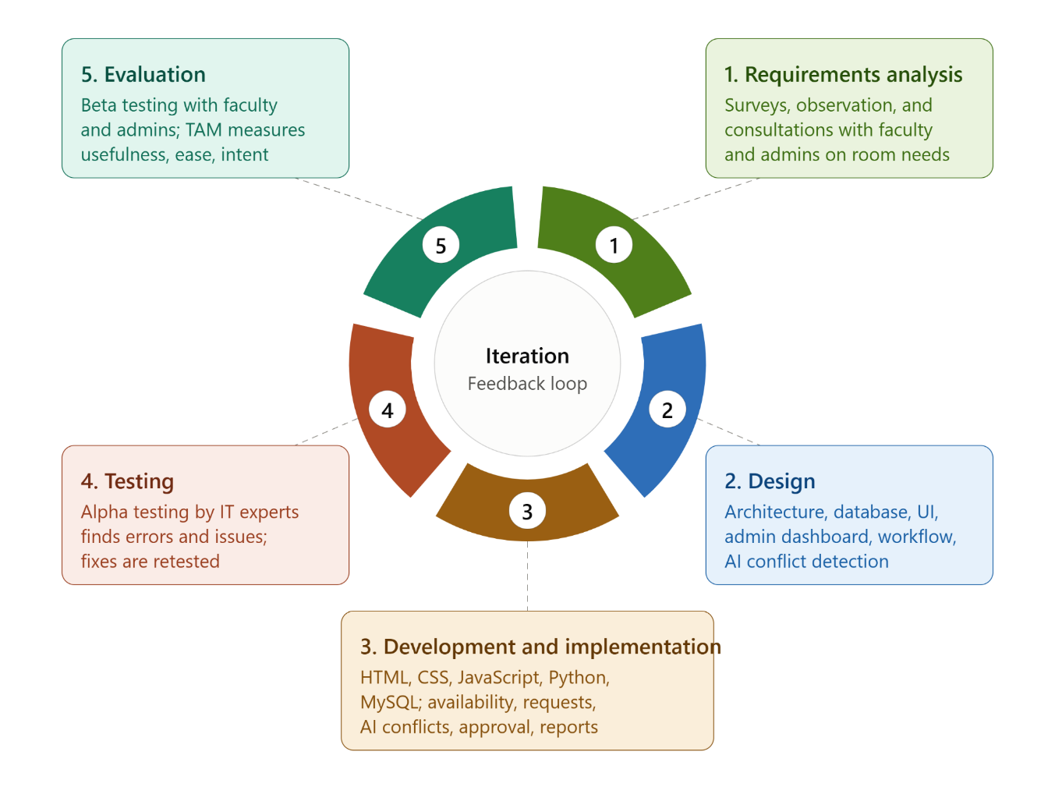
Figure 3 illustrates the Iterative Development Model adopted in the study and shows how each SDLC phase is aligned with the step-by-step algorithm of the proposed Web-Based Room Allocation and Reservation System with Artificial Intelligence-Based Conflict Detection and Administrative Approval. The figure emphasizes the cyclical and incremental nature of system development, where each phase is repeatedly refined based on testing results and user feedback.
The process begins with requirement analysis, where the system requirements are identified through observation, surveys, and consultations with faculty, administrators, and other authorized personnel. This phase focuses on identifying the needs related to room availability, reservation requests, scheduling conflicts, and administrative approval.
The design phase focuses on developing the system architecture, database structure, user interfaces, administrative dashboard, reservation workflow, and AI-based conflict detection process. The design ensures that the system functions are aligned with the identified requirements and user roles. Decision points and conditional processes are also considered during the design to determine how the system responds to different user inputs and reservation conditions.
During the development and implementation phase, the proposed web-based system is developed using HTML, CSS, JavaScript, Python, and MySQL. The system implements room availability monitoring, reservation requests, AI-based conflict detection, administrative approval, reservation management, and report generation. When a user submits a reservation request, the system checks the selected room, date, and time against existing reservation records. If no overlapping reservation is detected, the request proceeds to administrative approval. If an overlapping reservation is detected, the AI-based conflict detection process identifies the conflict and prevents the request from proceeding without appropriate resolution. The administrator then reviews the reservation request and decides whether to approve or reject it based on room availability and the identified conditions.
The testing phase involves verifying the functionality and reliability of the system. Alpha testing is conducted with information technology experts to identify errors, interface issues, and technical problems. The system also checks for invalid or incomplete inputs during reservation processing. Required information such as the room, date, time, and purpose must be provided before a request can be submitted. When a conflict, invalid input, or system error occurs, the system provides appropriate feedback to the user and allows the information to be corrected and resubmitted when applicable. Identified issues are corrected and tested again to improve system performance and reliability.
Finally, the evaluation phase gathers feedback from faculty members and administrators through beta testing. The Technology Acceptance Model (TAM) is used to assess perceived usefulness, perceived ease of use, and behavioral intention to use. The results guide further improvements, allowing the system to return to earlier stages and continuously evolve until it meets the identified requirements and user needs. Errors and unexpected conditions identified during evaluation are documented and addressed through subsequent iterations, providing a
Program Flow
The program flow of the Web-Based Room Allocation and Reservation System with Artificial Intelligence-Based Conflict Detection and Administrative Approval begins when an authorized user accesses the system through a web browser and continues until the reservation request is processed and the corresponding result is displayed. The system provides different functions according to the user's role, primarily the faculty or authorized user and the administrator. The users interact with the system through a centralized web interface, while the administrator manages room information, reviews reservation requests, detects scheduling conflicts, and provides approval or rejection. The flow involves room availability monitoring, reservation submission, AI-based conflict detection, administrative approval, reservation management, and report generation.
System Initialization and Access. A user accesses the system through a standard web browser using an available device connected to the First City Providential College network or an authorized connection. The system displays the login interface where the user provides the required account credentials. The system verifies the submitted credentials and determines the user's assigned role. If the credentials are valid, the user is granted access to the appropriate dashboard. If the credentials are invalid, the system displays an error notification and requires the user to provide the correct information before access is granted. The system provides different functions depending on the user's role to ensure that only authorized users can perform administrative operations.
User Workflow: Room Availability and Reservation Request. An authorized faculty member or user begins the reservation process by accessing the room availability section. The system displays available room and facility information, including the selected date and time. The user selects the desired room, date, time, and purpose of the reservation and submits the request. Before accepting the request, the system verifies that all required information has been provided. If required information is incomplete or invalid, the system displays an appropriate notification and allows the user to correct the information before resubmitting the request. If the information is complete, the reservation request proceeds to the AI-based conflict detection process.
AI-Based Conflict Detection. After a reservation request is submitted, the system checks the selected room or facility, date, and requested time against existing reservation records. The AI-based conflict detection process determines whether the requested schedule overlaps with an existing approved or active reservation. If no conflict is detected, the request proceeds to the administrative approval stage. If an overlapping reservation is detected for the same room or facility and schedule, the system identifies the conflict and informs the user that the requested schedule is unavailable or requires resolution. The system does not automatically approve a conflicting request. Instead, the user may modify the selected room, date, or time and submit the request again.
Administrator Workflow: Reservation Review and Approval. The administrator accesses the administrative dashboard to review submitted reservation requests. The dashboard displays the relevant reservation details, including the requesting user, selected room or facility, date, time, purpose, and conflict detection result. The administrator evaluates the request based on room availability, existing reservations, and the identified conditions. If the request satisfies the requirements and no unresolved conflict exists, the administrator may approve the reservation. If the request contains a conflict, invalid information, or does not satisfy the applicable requirements, the administrator may reject the request and provide an appropriate reason or status. The reservation status is then updated in the system and made available to the requesting user.
Reservation Status and Monitoring. After the administrator makes a decision, the system records the resulting reservation status and allows the authorized user to monitor the request. An approved reservation is reflected in the room availability information so that the reserved schedule is recognized in subsequent conflict detection processes. A rejected reservation is marked accordingly and does not block the room for the requested schedule. The user may review the status and, when necessary, submit a new reservation request using another available room or schedule. This process ensures that room availability and reservation records remain updated throughout the reservation cycle.
Room and Facility Management. Administrators can manage the room and facility information stored in the system. This includes adding, updating, or managing room details and availability information. When a room or facility is added or modified, the updated information becomes part of the data used by the reservation and conflict detection processes. If required room information is incomplete or invalid, the system prevents the information from being processed until the administrator provides the necessary details. This ensures that reservation requests are evaluated using current and valid room information.
Report Generation. After reservation records have been processed, the administrator can access the reporting function to generate information regarding room reservations and usage. The system retrieves the available reservation records and organizes them into reports that can assist administrators in monitoring room utilization, reservation activities, and approved or rejected requests. If no records are available for the selected reporting criteria, the system displays an appropriate notification instead of generating an incomplete report. The reports are based on the reservation information recorded by the system.
Exception Handling and Error Protocols. The system is designed to handle errors and unexpected conditions without interrupting the entire reservation process. Invalid login credentials result in an access notification and require the user to retry the login process. Incomplete or invalid reservation information is identified through input validation, and the user is prompted to correct the information before submission. If the AI-based conflict detection process identifies an overlapping reservation, the system does not proceed with an automatic approval and instead provides feedback regarding the detected conflict. If an administrator rejects a reservation, the system records the rejection and provides the corresponding status to the user. System errors encountered during reservation processing or data retrieval are reported through appropriate notifications, allowing the user or administrator to retry the operation when applicable. These procedures ensure that individual errors or invalid inputs do not compromise other reservation records or system operations.
Report Display and Process Completion. Once the reservation request has been processed, the system displays the appropriate result to the user, such as a pending, approved, or rejected reservation status. For administrators, the system provides the corresponding reservation management and reporting information through the dashboard. The process is considered complete when the reservation status and relevant information have been successfully recorded and displayed. Through this flow, the system provides a structured process from user access and room availability checking to reservation submission, AI-based conflict detection, administrative approval, status monitoring, and report generation.
Decision Points and Conditional Logic
- Building and Room Selection
Condition: the selected building is active, and the selected room is open for reservation, not under maintenance, and allowed for the requester's user type.
If true, the system accepts the selection and proceeds to reservation type selection.
If false, the system shows why the building or room is unavailable and asks the requester to choose another. The process does not advance until a valid room is selected.
- Date and Time Validity
Condition: the selected date is not in the past, the start time is earlier than the end time, and the time slot falls within the room's operating hours and allowed booking duration.
If true, the system accepts the schedule and proceeds to purpose and details.
If false, the system highlights the invalid entry, explains which rule was violated, and asks the requester to correct it before continuing.
- Purpose and Details Completeness
Condition: all required fields, such as purpose, number of attendees, and requester information, are filled in, and the attendee count does not exceed the room's capacity.
If true, the system passes the entry to AI Conflict Detection.
If false, the system flags the missing or invalid fields and keeps the requester on this step until the details are complete and within capacity.
- Conflict Detection
Condition: the room, date, and time selected by the requester do not overlap with an existing approved reservation or a reservation pending review.
If true (no conflict detected), the system accepts the entry and proceeds to submit the request to the administrator for review.
If false (conflict detected), the system blocks submission and displays the conflict details, including the existing booking, its time slot, and the overlapping period.
- Conflict Resolution
Condition: the system finds at least one alternative room or time slot that is free and suitable for the requester's needs.
If true, the system suggests the available alternatives and the requester selects one. The process then returns to the conflict check, so no double-booking can reach the administrator.
If false, the system informs the requester that no suitable alternative is available and prompts them to change the date, time, or room manually, or to cancel the attempt, which ends the process.
- Request Submission
Condition: the conflict check has passed and the request was saved successfully with a unique reference number and a status of "Pending."
If true, the request enters the administrator's review queue and the requester can track its status.
If false, the system displays a submission error, keeps the entered data so the requester does not start over, and prompts them to submit again.
- Administrative Approval
Condition: the administrator confirms that the purpose, details, schedule, and room availability are valid and that the requester is authorized to reserve the room.
If true (approved), the request is marked as approved (Request Approve) and the process moves to Notification.
If false (declined), the administrator records a reason, the request is marked as declined (Request Decline), and the process moves to Notification.
- Notification Delivery
Condition: the requester's contact channel, such as in-app notification or email, is valid and the message is sent successfully.
If true, the requester is informed of the decision. For approved requests, the process continues to update the calendar. For declined requests, no calendar or room status change is needed, and the process ends after the notification.
If false, the system logs the failed delivery, retries sending, and keeps the decision visible on the requester's dashboard. An approved reservation still proceeds to the calendar update, so a delayed notification does not block the booking.
- Calendar and Room Status Update
Condition: the approved time slot can be written to the room calendar without overlapping any existing entry, and the room's status can be updated to reflect the reservation.
If true, the slot is blocked for other users, the room status is updated, and the process proceeds to the final reservation step.
If false, the system keeps the previous status, logs a synchronization error, and alerts the administrator to correct the entry manually so the room is not shown as available when it is booked.
- Reservation Completion
Condition: the reservation type chosen at the start of the flow determines how the booking is finalized.
If the type is Quick Reserve, the system finalizes the booking immediately for short-notice use and marks it as active for the requested slot.
If the type is Reserve Room, the system finalizes it as a standard advance reservation, scheduled until the reserved date and time. In both cases, the process then ends.
Program Flow with Decision Points and Conditional Logic

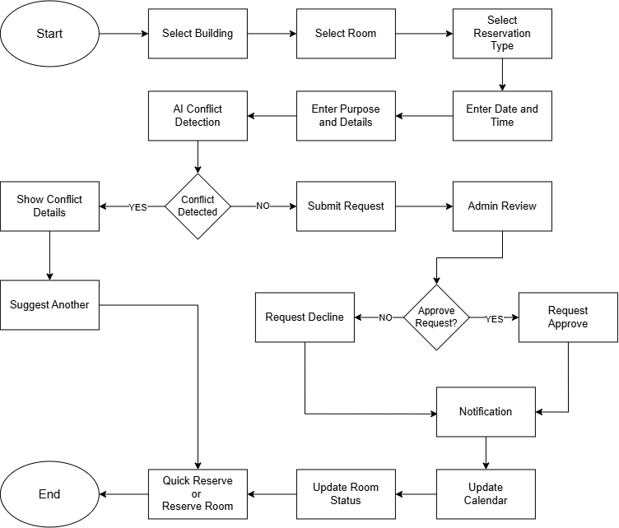
Figure 4 presents the program flow of the proposed AI-assisted room reservation system, highlighting the decision points and conditional logic used to automate conflict detection, request validation, and approval processing. The flowchart shows how the system makes systematic decisions at each stage to reduce scheduling errors and manual coordination while ensuring reliable and organized room reservations.
The process begins at the Start node, where the user initiates a reservation request. The system then guides the user through a sequence of input stages. The user first selects the building and then the specific room. The user then chooses the reservation type, enters the preferred date and time, and provides the purpose and details of the reservation. This step-by-step input process ensures that all information needed for validation is complete before the request is processed.
After the required information is collected, the request proceeds to the AI Conflict Detection stage. At this stage, the system checks the selected room, date, and time against existing reservations and schedules to identify overlapping or conflicting bookings.
The first decision point evaluates whether a conflict is detected. If a conflict is detected, the system displays the conflict details to the user and suggests another available room or time slot. The user is then directed to the Quick Reserve or Reserve Room stage to select an alternative, after which the process ends. If no conflict is detected, the system submits the request for administrative review, ensuring that only valid and conflict-free requests reach the administrator.
The second decision point occurs during the Admin Review stage, where the administrator evaluates the request based on its purpose, details, and room availability. If the request is declined, the system records the request as declined and proceeds to the Notification stage. If the request is approved, the system records it as approved and likewise proceeds to the Notification stage. In both cases, the requester is informed of the outcome, which keeps communication timely and transparent.
Following the notification, the system updates the calendar to reflect the latest reservation records and then updates the room status to keep the availability information accurate and to help prevent double booking. Once these updates are complete, the reservation is finalized through the Quick Reserve or Reserve Room stage, and the process reaches the End node.
Overall, the flowchart illustrates the sequential and decision-driven nature of the proposed system. It shows how conditional logic supports accurate conflict detection, structured administrative approval, and timely communication with users, while minimizing manual scheduling effort and booking errors.
Gantt Chart
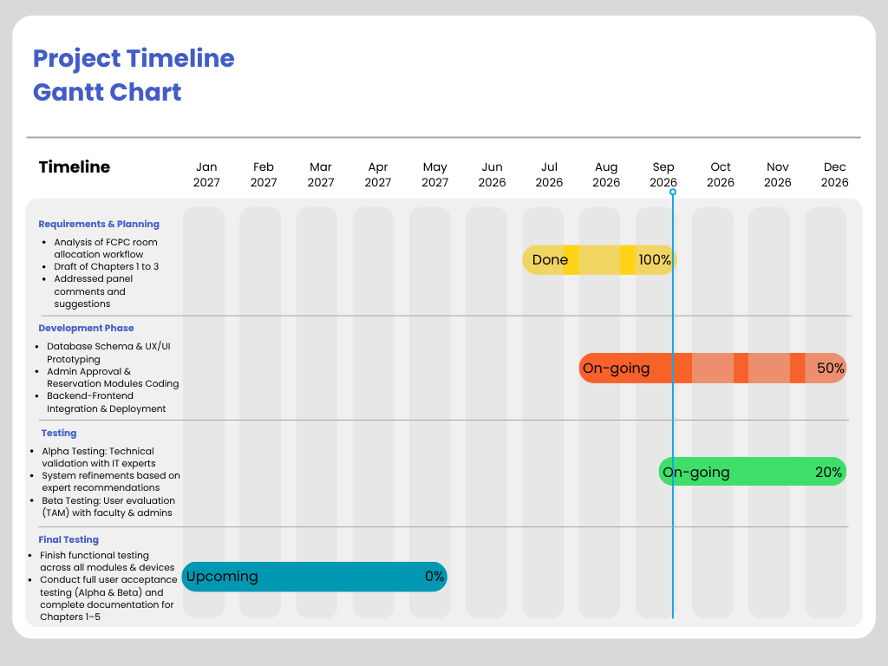
Project Timeline
August 2026 – Requirements & Planning Phase
- Analysis of FCPC room allocation workflow and existing manual reservation processes
- Completion of Chapters 1–3 (Introduction, Literature Review, and Methodology draft)
- Addressed panel comments and suggestions from proposal defense
- Finalized system architecture, D.I.E. conceptual framework, and problem statement
August to December 2026 – Development Phase
August–September: Architecture and UI Design
- Designed MySQL database schemas
- Drafted system UI/UX prototypes and interactive wireframes
October–November: Core Functionality and AI Module
- Developed Admin Approval and Room Reservation Modules using HTML, CSS, and JavaScript
- Implemented a Python-based AI conflict detection engine for automatic scheduling verification
December: Integration and Deployment
- Integrated Python AI backend with MySQL database and web interface
- Conducted deployment, initial unit testing, and bug fixing
September to December 2026 – System Testing Phase
September–October: Alpha Testing
- Conducted technical validation and code review with IT experts
- Implemented system refinements and module enhancements based on expert feedback
November–December: Beta Testing
- Initiated field evaluation with FCPC faculty members and system administrators
- Distributed and collected user acceptance questionnaires using the Technology Acceptance Model (TAM)
May 2027 – Final Testing and Documentation
- Finish functional testing across all modules, web browsers, and devices
- Perform data processing and statistical analysis on TAM survey results for Chapter 4
- Conduct full user acceptance testing and complete manuscript finalization for Chapters 1–5
- Prepare institutional implementation plan and final capstone defense submission

Human Resources Responsibilities
Project Manager—project coordination, scheduling, progress monitoring, and manuscript documentation
System Developers: backend coding, frontend UI/UX design, MySQL database implementation, and Python AI integration
IT Experts: technical validation, system architecture review, and Alpha testing
FCPC Faculty & Admin Staff: user acceptance walk-throughs, operational feedback, and Beta testing (TAM)
Software Requirements Specification (SRS)
This section presents the software requirements specifications (SRS) for the proposed web-based room allocation and reservation system with artificial intelligence-based conflict detection and administrative approval for First City Providential College. It defines the system’s functional and non-functional requirements, operational constraints, and user interactions necessary to support classroom and facility availability monitoring, reservation management, conflict detection, administrative approval, and reporting. The primary objective of the system is to provide a centralized platform for managing room and facility reservations, reducing scheduling conflicts, and improving the efficiency of the institution’s room allocation process.
Functional Requirements

The core functionality of the proposed system is to provide a centralized and web-based platform for monitoring classroom and facility availability and managing reservation requests at First City Providential College. The system shall allow authorized users to view available rooms and facilities based on the selected date and time, submit reservation requests, and monitor their reservation status. Reservation information shall include the requested room or facility, date, time, purpose, and requesting user, which shall be stored in a centralized database.

The system shall implement an artificial intelligence-based conflict detection feature to identify potential scheduling conflicts among reservations. The system shall check existing reservation records based on the selected room or facility, date, and overlapping time schedules. When a conflict is detected, the system shall notify the user and administrator before the request is approved. The AI-based conflict detection shall only assist in identifying conflicts and shall not automatically approve reservation requests.

Administrative approval shall be integrated into the reservation process. As an Administrator, the user shall be able to securely log in, manage room and building information, review submitted reservation requests and detect conflicts, approve or reject requests, monitor reservation activities, and generate reports. Approved and rejected reservations shall be recorded to maintain an organized history of reservation activities.

User interaction with the system shall be facilitated through a web-based interface based on the assigned user role. As a Faculty user, the user shall be able to view room and facility availability, submit reservation requests, receive conflict notifications, and monitor request status. As an Authorized Student Representative, the user shall be able to view availability and submit requests on behalf of a faculty member when properly authorized. The Dean shall be able to monitor room allocation and reservation activities through system information and reports, while the Registrar shall be able to access room assignment and reservation records. Researchers and evaluators shall be able to access appropriate system data and reports for evaluating usability, efficiency, and effectiveness.

The system shall also provide monitoring and reporting functionality to support administrative management. Reservation records shall be organized according to room or facility, date, time, requesting user, and reservation status. Authorized users shall be able to monitor reservation activities and review records, while generated reports shall provide information regarding room allocation and facility usage.

Non-Functional Requirements

To ensure effective operation, the system must satisfy several non-functional requirements. In terms of performance, the system shall provide timely access to room and facility availability and process reservation requests with minimal delay. Conflict detection shall be performed before administrative approval without significantly affecting normal system operations. The system shall also support multiple reservation records while maintaining acceptable response times.

With respect to security, the system shall implement secure authentication and role-based access control to restrict access to authorized users. Users shall only access functions and information appropriate to their assigned roles. Administrative functions such as approving reservations, managing rooms and buildings, and generating reports shall be limited to authorized personnel. User and reservation information shall be securely handled in accordance with the Data Privacy Act of 2012 (Republic Act No. 10173).

Usability is a critical requirement of the system. The web-based interface shall present room availability, reservation details, conflict notifications, approval status, and reports in a clear and organized manner. The system shall provide simple navigation and structured layouts so that faculty members, authorized student representatives, administrators, and other authorized users can perform their assigned tasks without extensive technical knowledge.

In terms of reliability, the system shall consistently maintain accurate reservation and room allocation records. Submitted requests, conflict detection results, approval decisions, and reservation statuses shall be preserved for monitoring and reporting. The system shall minimize duplicate and overlapping reservations by checking existing reservation records before approval and shall maintain data integrity when reservation or room information is updated.

Finally, the system must ensure compatibility with the required software environment, including HTML, CSS, and JavaScript for the web-based interface, Python for application development and artificial intelligence-based conflict detection, and MySQL for database management. The system shall be deployable within the computing environment of First City Providential College and shall focus on room allocation, facility availability, reservation management, conflict detection, administrative approval, monitoring, and reporting. It shall not include automatic class scheduling, automatic reservation approval, attendance monitoring, payment processing, external institutional-system integration, or IoT- and CCTV-based physical occupancy monitoring.
Algorithm
The algorithm intends to solve the problem of overlapping room reservations in First City Providential College, where two or more reservations might be assigned to the same room, same date, and overlapping time ranges. In the manual process, human checking subject to oversight and delays is the only way these conflicts come to light. The algorithm aims to automatically detect such conflicts before a reservation request is submitted to the administrator and propose the nearest available room or time slot in case a conflict is detected. The algorithm is the validation component of the system. When the user submits his reservation request, the algorithm checks for conflicts, and if there are none, it sends the reservation inquiry to the admin queue for approval.

The Conflict Detection Algorithm and the Constraint Satisfaction–Based Slot Suggestion Algorithm are the two processes that make up the algorithm.

A. Conflict Detection Algorithm
- Receive the reservation request containing the room identifier, reservation type (one-time or weekly), date or day of the week, start time, and end time.
- Validate that all required fields are present. If incomplete, return no conflict and wait for complete input.
- Retrieve all existing approved schedules assigned to the selected room.
- If the reservation type is one-time, derive the day of the week from the selected date, then check the request against both the schedules booked on that specific date and the recurring weekly schedules falling on that same day of the week.
- If the reservation type is weekly, check the request against the recurring weekly schedules assigned to the same day of the week.
- Apply the overlap condition: a conflict exists when the existing start time is earlier than the requested end time and the existing end time is later than the requested start time.
- If a conflict is found, flag the request, display the conflicting time range to the user, and prevent submission until the conflict is resolved.
- If no conflict is found, record the request in the pending schedule, generate a notification for the user, and forward the request to the administrative approval queue.

B. Constraint Satisfaction–Based Slot Suggestion Algorithm

- Receive the search parameters: building, room (optional), date, required duration, and preferred start time (optional).
- Define the domain of candidate start times within the institution's operating hours of 7:00 AM to 9:00 PM, divided into thirty-minute intervals.
- Retrieve all approved and pending reservations for the selected room on the given date and day of the week.
- Convert each reservation into a time interval and merge the overlapping or adjacent intervals into consolidated busy periods.
- Identify the free gaps between the merged busy periods that are equal to or longer than the required duration.
- Divide each free gap into candidate slots that satisfy the required duration.
- If the selected room yields few or no candidate slots, relax the room constraint and repeat steps 3 to 6 for the other available rooms within the same building.
- Rank the resulting candidate slots according to their closeness to the user's preferred start time.
- Return the ranked suggestions to the user, allowing the selected slot to be carried over to the reservation form.
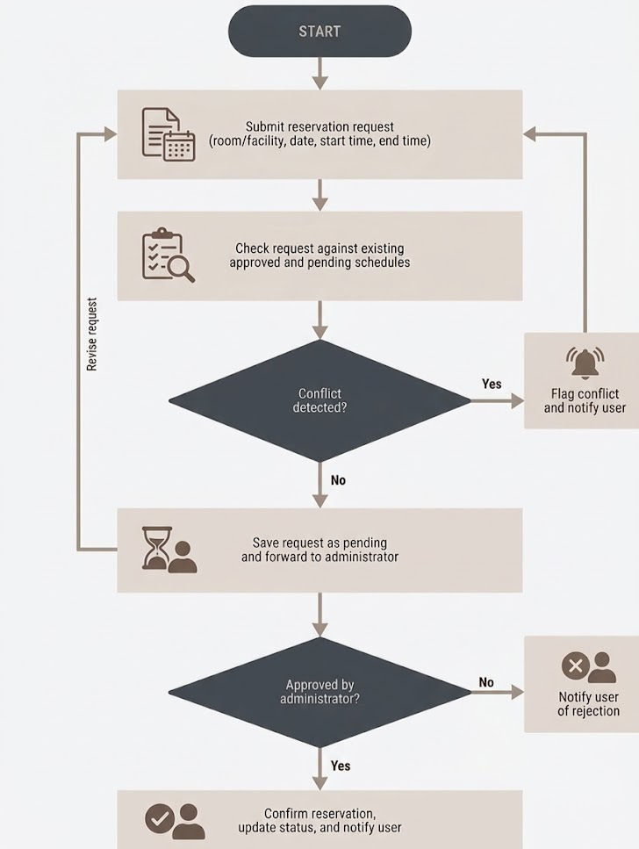
Figure ? shows the flowchart of the algorithm. The flowchart shows the flow from submission of a reservation request to conflict detection to generation of alternative slot suggestions and finally forwarding of conflict-able requests to the administrative approval queue.

Research Design
This study employs a descriptive-developmental research design with a quantitative method to analyze the existing room allocation and reservation process at First City Providential College (FCPC) and to develop a web-based room allocation and reservation system with artificial intelligence-based conflict detection and Administrative Approval. Descriptive research systematically describes conditions as they exist without manipulating variables (Deckert & Wilson, 2023), while developmental research focuses on the design, creation, and evaluation of a system or product intended to address identified problems. Salisi and Balahadia (2025) combined these approaches to build a decision support system for a Philippine higher education institution, refining it through continuous user feedback and evaluating it with faculty members and administrators. Mahat et al. (2024) also emphasize that the research design must match the objectives of the study. This design suits the present study because its objectives require both an accurate picture of the current problem and a working, evaluated solution, without the variable control that an experimental design would need.
The descriptive phase addresses the first specific objective, which is to analyze the existing room allocation and reservation process at FCPC, including the challenges encountered by faculty members and administrators. It documents the manual scheduling process, the reliance on Messenger and personal coordination, the room scheduling conflicts that result from manual checking, and the delays in finalizing room assignments. The findings from this phase serve as the basis for the system requirements, so the system is designed around the actual conditions at FCPC and not around assumptions.
The developmental phase follows the Development-Implement-Evaluate (D.I.E.) model of the study and addresses the second to fourth specific objectives. In the development stage, the system is designed and built using HTML, CSS, JavaScript, Python, and MySQL, with features for room and facility availability monitoring, room reservation requests, AI-based conflict detection, administrative approval, room and building management, reservation monitoring, and report generation. The conflict detection module is grounded in Constraint Satisfaction Problem (CSP) principles, and the approval workflow in Decision Support System (DSS) principles. In the implementation and evaluation stages, the system first undergoes alpha testing with Information Technology experts to identify revisions and improve functionality. It is then evaluated through beta testing with faculty members and administrators using the Technology Acceptance Model (TAM), measured in terms of perceived usefulness, perceived ease of use, and behavioral intention to use. The quantitative approach is appropriate for this stage because user ratings can be collected through structured questionnaires and summarized using descriptive statistics. Finally, the results of the beta testing serve as the basis for the proposed implementation and utilization plan for the institutional adoption of the system, which addresses the fifth specific objective.

REFERENCES
Artes, A. L., Lorzano, E. R., et al. (2024). Cardinal Reserve: A Proposed Online Room Reservation System for a Higher Educational Institution (HEI).https://www.researchgate.net/publication/383016195_Cardinal_Reserve_A_Proposed_Online_Room_Reservation_System_for_a_Higher_Educational_Institution_HEI
Abubakar, S., et al. (2026). Design and implementation of a web-based lecture timetable scheduling system. https://journals.mmupress.com/index.php/jiwe/article/view/1990
Antunes-Batista, J., et al. (2026). Multiobjective optimization approaches for room allocation in university course timetabling. Procedia Computer Science. https://www.sciencedirect.com/science/article/pii/S1877050926006290
Ajith, R., et al. (2025). Campus Venue Booking System. REST Journal on Data Analytics and Artificial Intelligence. https://doi.org/10.46632/jdaai/4/1/13
Amare, E. M., et al. (2024). Educational technology acceptance among faculty members. https://doi.org/10.1007/s44217-024-00090-1
Barakat, M., et al. (2025). University educators’ perspectives on ChatGPT: A Technology Acceptance Model-based study. https://doi.org/10.55982/openpraxis.17.1.718
Bashab, A., et al. (2023). Optimization techniques in university timetabling problem: Constraints, methodologies, benchmarks, and open issues. https://doi.org/10.32604/cmc.2023.034051
Boufflet, J. P., et al. (2021). The student scheduling problem. Expert Systems with Applications. https://doi.org/10.1016/j.eswa.2021.114735
Casey, J. E., Kirk, J., Kuklies, K., & Mireles, S. V. (2023). Using the Technology Acceptance Model to assess how preservice teachers’ view educational technology in middle and high school classrooms. Education and Information Technologies, 28(2), 2361–2382. https://doi.org/10.1007/s10639-022-11263-6
Chahal, J., et al. (2022). Exploring the acceptance for e-learning among higher education students in India: Combining Technology Acceptance Model with external variables. https://doi.org/10.1007/s12528-022-09327-0
Chen, M., Werner, F., & Shokouhifar, M. (2023). Mathematical modeling and exact optimizing of university course scheduling considering preferences of professors. Axioms, 12(5), 498. https://doi.org/10.3390/axioms12050498
Chong, J. L. E., et al. (2024). U-Reserve: Development of a facility reservation system for UCSI University. https://doi.org/10.5954/ICAROB.2024.OS18-7
Cruz-Rosales, M. H., et al. (2022). Metaheuristic with cooperative processes for university course timetabling. Applied Sciences. https://doi.org/10.3390/app12020542
Diallo, F. P., et al. (2024). Optimizing the scheduling of teaching activities in a faculty. https://doi.org/10.3390/app14209554
Django Software Foundation. (2025). Django documentation. https://docs.djangoproject.com/
Dunke, F., & Nickel, S. (2023). A matheuristic for customized multi-level multi-criteria university timetabling. https://doi.org/10.1007/s10479-023-05325-2
European Commission. (2022). Digital education action plan: Policy background. https://education.ec.europa.eu/focus-topics/digital-education/action-plan
Fink, A., Spoden, C., & Frey, A. (2023). Determinants of higher education teachers’ intention to use technology-based exams. https://doi.org/10.1007/s10639-022-11435-4
Flask Documentation. (2025). Flask documentation. https://flask.palletsprojects.com/
García-Granja, M. J., et al. (2022). Development of an innovative seat reservation system for university buildings based on BIM technology. Buildings. https://doi.org/10.3390/buildings12111786
Ghimire, A., et al. (2024). Generative AI adoption using TAM and Innovation Diffusion Theory. https://arxiv.org/abs/2406.15360
Hidayat, W. M., et al. (2025). Technology fit and user acceptance in academic information systems. https://doi.org/10.59562/intec.v4i1.7478
Ibrahim, K. A. (2023). Classroom allocation for Ashesi University: A semi-automated web application for allocating classrooms at Ashesi University. https://hdl.handle.net/20.500.11988/1034
Ilhan, M. S., et al. (2026). FSKTM Faculty Room Reservation System. https://periodical.uthm.edu.my/index.php/aitcs/article/view/20330
Kampa, R. K. (2023). Combining technology readiness and acceptance model for investigating the acceptance of m-learning in higher education in India. https://doi.org/10.1108/AAOUJ-10-2022-0149
Karthika, S., et al. (2025). A web-based automated library hall booking and management system. International Research Journal of Education and Technology. https://www.irjweb.com/user_upload/A%20Web-Based%20Automated%20Library%20Hall%20Booking%20and%20Management%20System.pdf
Lin, Y., et al. (2023). Digital academic reading tools and Technology Acceptance Model. https://doi.org/10.1186/s41239-023-00403-8
Lin, Y., & Yu, Z. (2023). Extending Technology Acceptance Model to higher-education students’ use of digital academic reading tools on computers. https://doi.org/10.1186/s41239-023-00403-8
Medallo, J. R., et al. (2026). Automating academic resource management: Design, implementation, and quality evaluation of an integrated faculty loading, room, and class scheduling system. https://doi.org/10.47760/IJCSMC.2026.V15I03.002
Meier, F., et al. (2026). Multi-objective curriculum-based course timetabling. https://arxiv.org/abs/2606.21176
Mohammad, M., et al. (2025). Faculty adoption of AI tools. https://doi.org/10.5171/2025.4624325
Mokhtari, M., et al. (2021). Developing a model for the university course timetabling problem: A case study. https://doi.org/10.1155/2021/9940866
Mozilla Developer Network. (2025). CSS documentation. https://developer.mozilla.org/en-US/docs/Web/CSS
Mozilla Developer Network. (2025). HTML documentation. https://developer.mozilla.org/en-US/docs/Web/HTML
Mozilla Developer Network. (2025). JavaScript guide. https://developer.mozilla.org/en-US/docs/Web/JavaScript/Guide
MySQL. (2025). MySQL 8.4 reference manual. https://dev.mysql.com/doc/refman/8.4/en/
National Institute of Standards and Technology. (2024). Artificial intelligence risk management framework. https://doi.org/10.6028/NIST.AI.600-1
National Institute of Standards and Technology. (2024). Cybersecurity framework 2.0. https://doi.org/10.6028/NIST.CSWP.29
OECD. (2023). Digital education outlook 2023. https://doi.org/10.1787/c74f03de-en
Oude Vrielink, T. (2025). Improving the quality of classroom allocation in higher education: Towards efficient and effective use of space. University of Twente. https://research.utwente.nl/en/publications/improving-the-quality-of-classroom-allocation-in-higher-education/

OWASP. (2025). Authentication cheat sheet. https://cheatsheetseries.owasp.org/cheatsheets/Authentication_Cheat_Sheet.html
OWASP. (2025). Authorization cheat sheet. https://cheatsheetseries.owasp.org/cheatsheets/Authorization_Cheat_Sheet.html
OWASP. (2025). SQL injection prevention cheat sheet. https://cheatsheetseries.owasp.org/cheatsheets/SQL_Injection_Prevention_Cheat_Sheet.html
Petering, M. E. H., et al. (2024). University course scheduling during a pandemic. https://arxiv.org/abs/2407.07355
Python Software Foundation. (2025). Python documentation. https://docs.python.org/3/
Quiban, J. B. (2025). Faculty acceptance of LMS in Philippine higher education. https://doi.org/10.69478/BEST2025v1n1a016
Rappos, E., Thiémard, E., Robert, S., & Hêche, J.-F. (2022). A mixed-integer programming approach for solving university course timetabling problems. Journal of Scheduling, 25, 391–404. https://doi.org/10.1007/s10951-021-00715-5
Robinson, T. (2025). Generative artificial intelligence in higher education. https://eric.ed.gov/?id=EJ1476718
Rosli, M. S., et al. (2022). A systematic review of the Technology Acceptance Model for the sustainability of higher education during the COVID-19 pandemic and identified research gaps. https://doi.org/10.3390/su141811389
Scherer, R., Siddiq, F., & Tondeur, J. (2022). Technology acceptance in education. https://doi.org/10.1007/s10639-022-10951-7
Shree S., et al. (2025). Web based Venue Booking System. International Journal of Research Publication and Reviews. https://doi.org/10.55248/gengpi.6.0425.1303
Simangunsong, G. A., et al. (2025). Development of a web-based classroom reservation system using the Agile Scrum methodology. https://doi.org/10.52661/jict.v7i1.409
Triswinadi, M. W., et al. (2024). Room reservation integration design to simplify learning process in university. https://doi.org/10.36418/syntax-literate.v9i8.16997
UNESCO. (2021). AI and education: Guidance for policy-makers. https://unesdoc.unesco.org/ark:/48223/pf0000376709
UNESCO. (2023). Guidance for generative AI in education and research. https://unesdoc.unesco.org/ark:/48223/pf0000386693
Vega, M. M., et al. (2025). EReserve: An online facility reservation system of one Philippine higher education institution. https://ejournals.ph/article.php?id=30627
Wahyuningsih, S. S., et al. (2024). Technology Acceptance Model and DeLone and McLean model in higher education. https://doi.org/10.60083/jidt.v6i1.470
Wang, J., et al. (2024). Application and implementation of micro-classroom reservation system in universities. https://doi.org/10.5281/zenodo.10650780
World Bank. (2023). Digital technologies in education. https://www.worldbank.org/en/topic/edutech
World Wide Web Consortium. (2023). Web content accessibility guideline. https://www.w3.org/TR/WCAG22/
Wu, K., et al. (2025). Digital twin-driven recommendation system for adaptive campus course timetabling. https://arxiv.org/abs/2503.06109
Zefanya, Y., et al. (2026). Optimizing campus sustainability, an academic portal-based classroom management system for resolving scheduling conflicts. http://journal.perbanas.id/index.php/Proficient/article/view/1298
Rasoanaivo, R. G., et al. (2022). A Decision Support System for student's room allocation. https://hal.science/hal-03726288/
Sharma, A., et al. (2021). Hostel’s Room Allocation System: A Framework Using Single-layer Fuzzy Logic. https://papers.ssrn.com/sol3/papers.cfm?abstract_id=3833297
Tahira, U. R., et al. (2026). Optimizing Patient Admission and Room Allocation in Cloud-Enabled Healthcare System. https://doi.org/10.1080/02564602.2026.2688070
Dastres, R., et al. (2021). Advances in Web-Based Decision Support Systems. https://hal.science/hal-03367778/
Zahri. M., et al. (2023). Use of the latest web technology in school website development. https://pdfs.semanticscholar.org/6d92/bd273e365ee27e6486f7f873d047446076df.pdf
Wu, X., et al. (2024). The China Active Faults Database (CAFD) and its web system. https://essd.copernicus.org/articles/16/3391/2024/
Tiwari, A., et al. (2022). Reservation System for Cloud Computing Resources (RSCC): Immediate Reservation of the Computing Mechanism. https://www.igi-global.com/journal/international-journal-cloud-applications-computing/41974
Yoganandham, G., et al. (2023). An Evaluation of the Reservation System in India. https://d1wqtxs1xzle7.cloudfront.net/111053325/An_Evaluation_of_the_Reservation_System_in_India-libre.pdf?
Siti, A. E., et al. (2021). Online reservation system and online customer review: Its impact on brand image, trust and hotel booking decision. https://doi.org/10.29040/ijebar.v5i4.3367
Dimitriadou, E., et al. (2023). A critical evaluation, challenges, and future perspectives of using artificial intelligence and emerging technologies in smart classrooms. https://link.springer.com/article/10.1186/s40561-023-00231
Huynh-The, T., et al. (2023). Artificial intelligence for the metaverse: A survey. https://doi.org/10.1016/j.engappai.2022.105581
Ghosh, M., et al. (2021). Introduction to Artificial Intelligence. https://link.springer.com/chapter/10.1007/978-981-16-0415-7_2
Heyne, D., et al. (2025). Addressing authorized absences: a school district’s initiative to examine prevalence and promote proactive attendance practices. https://www.frontiersin.org/journals/education/articles/10.3389/feduc.2025.1546046/full
Ezawa, Y., et al. (2023). Blockchain-based cross-domain authorization system for user-centric resource sharing. https://doi.org/10.1016/j.bcra.2023.100126
Ahmad Agin, N. H., et al. (2022). Examination Authorized System (EASy): Design Development. https://journal.uniten.edu.my/index.php/ijbm/article/view/269
Salyers, A. J., et al. (2025). Building and Beta-Testing Be Well Buddy Chatbot, a Secure, Credible and Trustworthy AI Chatbot That Will Not Misinform, Hallucinate or Stigmatize Substance Use Disorder: Development and Usability Study. https://humanfactors.jmir.org/2025/1/e69144
Bloch, D., et al. (2024). NAMs: Beta testing needed. https://doi.org/10.1016/j.cotox.2024.100490
Flammang, B. E., (2022). Bioinspired Design in Research: Evolution as Beta-Testing. https://doi.org/10.1093/icb/icac134
Wang, Zhe., et al. (2025). An investigation into the acceptance of intelligent care systems: an extended technology acceptance model (TAM). https://www.nature.com/articles/s41598-025-02746-w
Marikyan, D., et al. (2024). Technology Acceptance Model: A review. https://eprints.ncl.ac.uk/302879
Aburbeian, A. M., et al. (2022). A Technology Acceptance Model Survey of the Metaverse Prospects. https://doi.org/10.3390/ai3020018
Mammadova, G., et al. (2024). “Schedule” System for Universities Under the Bologna Education Process. https://link.springer.com/chapter/10.1007/978-3-031-73420-5_32
Meng, F., et al. (2022). Construction Schedule Management System for Large-Scale Construction Projects Based on Multisensor Network. https://doi.org/10.1155/2022/3003552
Chen, X., et al. (2021). Design and Application of an Improved Genetic Algorithm to a Class Scheduling System. https://www.learntechlib.org/p/218642/
Jiang, T., et al. (2025). An analysis of the impact of administrative approval reform on the technological complexity of manufacturing exports. https://doi.org/10.1371/journal.pone.0319734
Cheng, B., et al. (2023). Does the administrative approval reform impact firm's investment decisions?. https://www.sciencedirect.com/science/article/abs/pii/S1059056023002459
Zhu, G., et al. (2021). Administrative approval reform and the quality of economic development. https://www.sciencedirect.com/science/article/pii/S2666933121000368
Taipalus, T. (2024). Vector database management systems: Fundamental concepts, use-cases, and current challenges. https://www.sciencedirect.com/science/article/pii/S1389041724000093
Sharma, A., et al. (2021). Database Management Systems—An Efficient, Effective, and Augmented Approach for Organizations. https://link.springer.com/chapter/10.1007/978-981-16-4177-0_47
Zaabar, B., et al. (2021). HealthBlock: A secure blockchain-based healthcare data management system. https://www.sciencedirect.com/science/article/abs/pii/S1389128621004382
Deckert, J., & Wilson, M. (2023). Descriptive research methods. In T. Welsh, J. P. Ambegaonkar, & L. Mainwaring (Eds.), Research methods in the dance sciences (pp. 153–165). University Press of Florida. https://doi.org/10.5744/florida/9780813069548.003.0011
Mahat, D., et al. (2024). Quantitative research design and sample trends. Cognizance Journal of Multidisciplinary Studies, 4(2), 20–27. https://cognizancejournal.com/vol4issue2/V4I201.pdf
Salisi, G. P., & Balahadia, F. F. (2025). EduComply: A progress tracking system for compliance in teaching-learning deliverables using decision support system. International Journal of Science, Technology, Engineering and Mathematics, 5(3), 40–78. https://doi.org/10.53378/ijstem.353240

hdddssaasasaasasa
heyehey

he

hhhde

A critical evaluation, challenges, and future perspectives of using artificial intelligence and emerging technologies in smart classrooms
A critical evaluation, challenges, and future perspectives of using artificial intelligence and emerging technologies in smart classrooms
A critical evaluation, challenges, and future perspectives of using artificial intelligence and emerging technologies in smart classrooms

